

Ordination
of Priests

Saturday 30th September 2023
at 11.00am



Growing in Christ since AD604

Welcome to Rochester Cathedral – a place of Christian worship since AD604.

Please be aware that this service is being live streamed. If you do not wish to be filmed or have any concerns, please make yourself known to one of the stewards.

Invitations as to posture are indicative – please stand/sit as you are able.


Please do not take photographs,
sound or video recordings during the service.
As part of our safeguarding, no photography of children
is permitted in the Cathedral.


An induction loop system is installed in the Cathedral.
Hearing aid users should adjust their aid to T.


Large print orders of service are available.

Copyright words and music for the musical items are reproduced under
Christian Copyright Licence number 31535,
CCLI Music Reproduction Licence number 903106 and Calamus Licence number 1019.
Material from Common Worship which is included in this service is copyright: © The Archbishops Council, 2000
Quotations from The New Revised Standard Version of the Bible,
Anglicized Edition, are copyright © 1989, 1995 by the Division of Christian Education of the National Council of Churches
in the USA, and are used by permission. All rights reserved.

The Ordination of Priests

The ministry of the Church is the ministry of Christ, its chief shepherd and high priest. The ordained ministry is Christ’s gift to his Church, and in their life and ministry, bishops, priests and deacons are called to speak in Christ’s name and build up the Church of which he is the head. In this way the whole body of the Church is ordered in faithful response to the Lord’s summons to share his work.

The ministry of priests is focussed in calling the Church to enter into Christ’s self-offering to the Father, drawing God’s people into a life transformed and sanctified.

from ‘Introduction by the House of Bishops’ to
Common Worship: Ordination Services (2007)

Before this service, the Ordinands have taken the Oath of Allegiance to His Majesty the King and the Oath of Canonical Obedience to the Bishop, and made the following Declaration of Assent:

Preface

The Church of England is part of the One, Holy, Catholic, and Apostolic Church, worshipping the one true God, Father, Son, and Holy Spirit. It professes the faith uniquely revealed in the Holy Scriptures and set forth in the catholic creeds, which faith the Church is called upon to proclaim afresh in each generation. Led by the Holy Spirit, it has borne witness to Christian truth in its historic formularies, the Thirty-nine Articles of Religion, The Book of Common Prayer and the Ordering of Bishops, Priests and Deacons. In the declaration you are about to make, will you affirm your loyalty to this inheritance of faith as your inspiration and guidance under God in bringing the grace and truth of Christ to this generation and making Him known to those in your care?

Declaration of Assent

I, N, do so affirm, and accordingly declare my belief in the faith which is revealed in the Holy Scriptures and set forth in the catholic creeds and to which the historic formularies of the Church of England bear witness; and in public prayer and administration of the sacraments, I will use only the forms of service which are authorized or allowed by Canon.
Ordinands

Alexander Coakley-Youngs
to serve in the benefice of Christ Church, Dartford

Rachel Curley
to serve in the benefice of St Nicholas, Chislehurst

Martin Hayward
to serve in the benefice of Chelsfield with Green Street Green and Pratts Bottom

Caroline (Caz) Mills
to serve in benefice of St James, Tunbridge Wells

Kelly-Ann Parsons
to serve in the Kent Downs & Malling Team

Oliver Phipps
to serve in the benefice of Yalding with Collier Street

Ruth Teruel-Pyrke
to serve in the benefice of St Peter with St Margaret, Rochester
and the benefice of St Matthew, Borstal

Simon Whiteside
to serve in the benefice of Pembury

Pray for all those to be ordained priest today, as they begin their new ministry.

ORDER OF SERVICE

The Dean, the Very Reverend Dr Philip Hesketh, welcomes the congregation and gives out any notices. Remain seated as supporting clergy, LLMs, readers and choir process to their seats. The choir sings the anthem: ‘I was glad when they said unto me’ a version of Psalm 122: 1-3,6,7 by Charles Hurbert Hastings Parry (1848-1918)

The Gathering and Presentation

All Stand as the procession enters the Nave via the Great West Door and sing:

Hymn
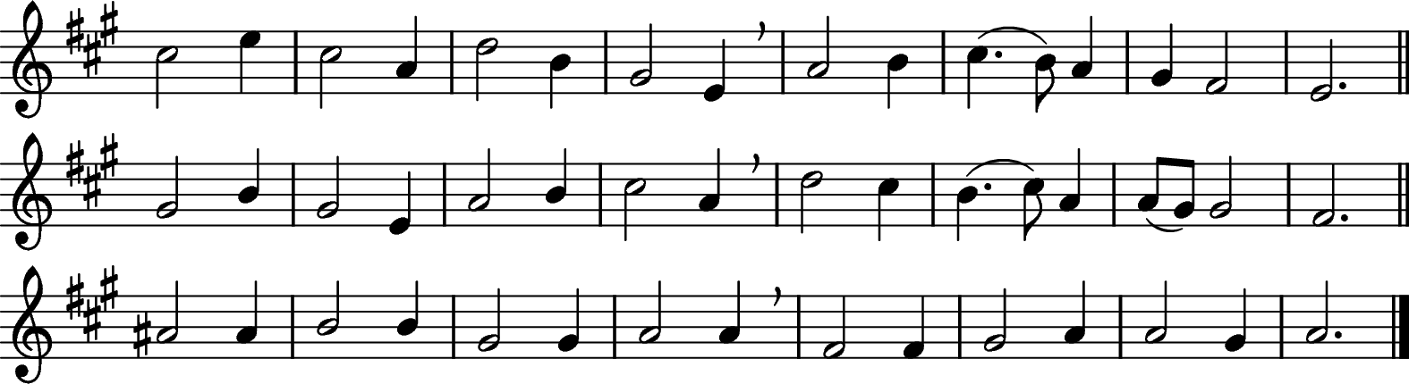
³ To this temple, where we call thee,
Come, O Lord of hosts, today;
With thy wonted loving-kindness,
Hear thy people as they pray;
And thy fullest benediction
Shed within its walls for ay.

⁴ Here vouchsafe to all thy servants
Gifts of grace by prayer to gain;
Here to have and hold for ever,
Those good things their prayers obtain,
And hereafter, in thy glory,
With thy blessèd ones to reign.

¹ Christ is made the sure foundation,
And the precious corner-stone,
Who, the two walls underlying,
Bound in each, binds both in one,
Holy Sion’s help for ever,
And her confidence alone.

² All that dedicated city,
Dearly loved by God on high,
In exultant jubilation
Pours perpetual melody
God the One, in Threefold glory,
Singing everlastingly.

⁵ Laud and honour to the Father,
Laud and honour to the Son,
Laud and honour to the Spirit,
Ever Three and ever One,
One in love, and One in splendour,
While unending ages run. Amen.

Westminster Abbey (205) ~ Belville in The Psalmist (1843) J.M. Neale (1818-1866)

Remain standing

Bishop Blessed be God, Father, Son and Holy Spirit.
All Blessed be his kingdom, now and for ever. Amen.

There is one body and one spirit.
All There is one hope to which we were called;

one Lord, one faith, one baptism,
All one God and Father of all.

Peace be with you
All and also with you.

Sit

The Bishop introduces the service

God calls his people to follow Christ, and forms us into a royal priesthood, a holy nation, to declare the wonderful deeds of him who has called us out of darkness into his marvellous light.

The Church is the Body of Christ, the people of God and the dwelling-place of the Holy Spirit. In baptism the whole Church is summoned to witness to God’s love and to work for the coming of his kingdom.

To serve this royal priesthood, God has given particular ministries. Priests are ordained to lead God’s people in the offering of praise and the proclamation of the gospel. They share with the Bishop in the oversight of the Church, delighting in its beauty and rejoicing in its well-being. They are to set the example of the Good Shepherd always before them as the pattern of their calling. With the Bishop and their fellow presbyters, they are to sustain the community of the faithful by the ministry of word and sacrament, that we all may grow into the fullness of Christ and be a living sacrifice acceptable to God.

Prayers of Penitence

The Deacon of the Liturgy, the Revd Jayne Shillito, says

Deacon As we gather before God,
and trusting in his grace alone,
let us join with these ordinands in confessing our sins.

After a silence

All Almighty God, our heavenly Father,
we have sinned against you
and against our neighbour
in thought and word and deed,
through negligence, through weakness,
through our own deliberate fault.
We are truly sorry
and repent of all our sins.
For the sake of your Son Jesus Christ,
who died for us,
forgive us all that is past
and grant that we may serve you in newness of life
to the glory of your name.
Amen.

Bishop Almighty God,
who forgives all who truly repent,
have mercy upon you,
pardon and deliver you from all your sins,
confirm and strengthen you in all goodness,
and keep you in life eternal;
through Jesus Christ our Lord.
All Amen.

The Presentation

Each Archdeacon presents the Ordinands from their Archdeaconry.

Archdeacon Reverend Father in God,
I present the following
to be ordained to the office of priest in the Church of God …

When the Ordinands have been presented, The Bishop asks the
Initial Ministerial Education Phase 2 Co-ordinator

Bishop Have those whose duty it is to know these ordinands and examine them found them to be of godly life and sound learning?

IME Co They have.

Bishop Do they believe them to be duly called to serve God in this ministry?

IME Co They do.

The Bishop addresses the Ordinands

Bishop Do you believe that God is calling you to this ministry?

Ordinands I do so believe.

Bishop I invite the Archdeacon to confirm that the Ordinands have taken the necessary oaths and made the Declaration of Assent.

Archdeacon They have duly taken the oath of allegiance to the Sovereign and the oath of canonical obedience to the bishop. They have affirmed and declared their belief in 'the faith which is revealed in the Holy Scriptures and set forth in the catholic creeds and to which the historic formularies of the Church of England bear witness'.

The Collect

Bishop Let us pray for those to be ordained today,
and for the ministry of the whole people of God.

After a short period of silent prayer:

God our Father, Lord of all the world,
through your Son you have called us into the fellowship
of your universal Church:
hear our prayer for your faithful people
that in their vocation and ministry
each may be an instrument of your love,
and give to your servants now to be ordained
the needful gifts of grace;
through our Lord and Saviour Jesus Christ,
who is alive and reigns with you,
in the unity of the Holy Spirit,
one God, now and for ever.
All Amen.

Sit
The Liturgy of the Word

First Reading: Isaiah 43. 1-3a
read by Rupert Phipps

A reading from the prophecy of Isaiah.

But now thus says the Lord,
he who created you, O Jacob,
he who formed you, O Israel:
Do not fear, for I have redeemed you;
I have called you by name, you are mine.
When you pass through the waters, I will be with you;
and through the rivers, they shall not overwhelm you;
when you walk through fire you shall not be burned,
and the flame shall not consume you.
For I am the Lord your God, the Holy One of Israel, your Saviour.

Reader For the word of the Lord.
All Thanks be to God.

Stand

Hymn

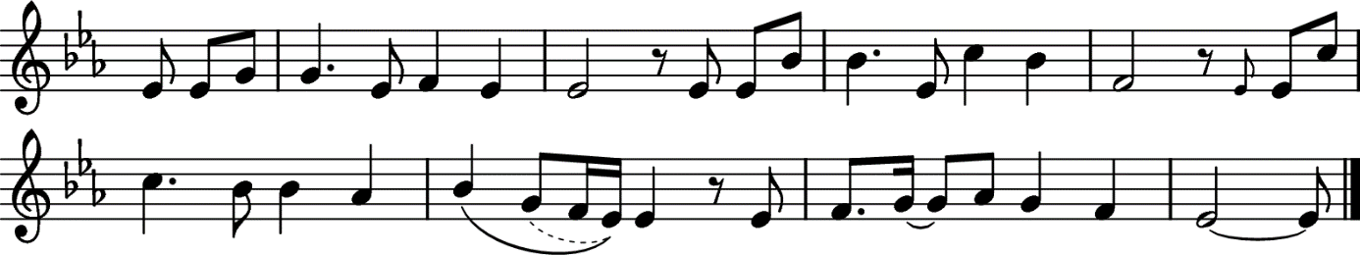

The Lord’s my shepherd, I’ll not want;
He makes me lie in pastures green.
He leads me by the still, still waters,
His goodness restores my soul.

And I will trust in You alone,
And I will trust in You alone,
For Your endless mercy follows me,
Your goodness will lead me home.

He guides my ways in righteousness,
And He anoints my head with oil,
And my cup, it overflows with joy,
I feast on His pure delights.

And though I walk the darkest path,
I will not fear the evil one,
For You are with me, and Your rod and staff
Are the comfort I need to know.

Stuart Townend (b.1963) (AM 800) Psalm 23

Sit

Second Reading: 1 Corinthians 1.18-25
read by Revd Ethlyn Roy Johnson, Formation and Ministry Administrator

A reading from the first letter of Paul to the Corinthians.

For the message about the cross is foolishness to those who are perishing, but to us who are being saved it is the power of God. For it is written,
‘I will destroy the wisdom of the wise,
and the discernment of the discerning I will thwart.’
Where is the one who is wise? Where is the scribe? Where is the debater of this age? Has not God made foolish the wisdom of the world? For since, in the wisdom of God, the world did not know God through wisdom, God decided, through the foolishness of our proclamation, to save those who believe. For Jews demand signs and Greeks desire wisdom, but we proclaim Christ crucified, a stumbling-block to Jews and foolishness to Gentiles, but to those who are the called, both Jews and Greeks, Christ the power of God and the wisdom of God. For God’s foolishness is wiser than human wisdom, and God’s weakness is stronger than human strength.

Reader For the word of the Lord.
All Thanks be to God.

Stand

Gospel Acclamation
Turn to face the gospel book as it passes through the congregation

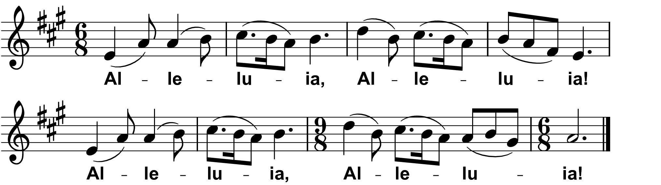
Fintan O'Carroll / Christopher Walker © 1985 OCP Publications

Choir Alleluia, Alleluia! Alleluia, Alleluia!
All Alleluia, Alleluia! Alleluia, Alleluia!

Choir I chose you and appointed you, says the Lord,
that you should go and bear fruit that shall last.
All Alleluia, Alleluia! Alleluia, Alleluia!
Gospel Reading: Luke 10.1-9

Deacon The Lord be with you
All and also with you

Deacon Hear the Gospel of our Lord Jesus Christ according to Luke.
All Glory to you, O Lord.

After this the Lord appointed seventy others and sent them on ahead of him in pairs to every town and place where he himself intended to go. He said to them, ‘The harvest is plentiful, but the labourers are few; therefore ask the Lord of the harvest to send out labourers into his harvest. Go on your way. See, I am sending you out like lambs into the midst of wolves. Carry no purse, no bag, no sandals; and greet no one on the road. Whatever house you enter, first say, “Peace to this house!” And if anyone is there who shares in peace, your peace will rest on that person; but if not, it will return to you. Remain in the same house, eating and drinking whatever they provide, for the labourer deserves to be paid. Do not move about from house to house. Whenever you enter a town and its people welcome you, eat what is set before you; cure the sick who are there, and say to them, “The kingdom of God has come near to you.”

Deacon This is the Gospel of the Lord.
All Praise to you, O Christ.

All Alleluia, Alleluia! Alleluia, Alleluia!

Once the Sermon has been introduced, please sit

Sermon
by The Right Reverend Simon Burton-Jones, Bishop of Tonbridge

Stand

The Creed

Bishop Let us declare our faith in God,
Father, Son and Holy Spirit.

All We believe in one God,
the Father, the Almighty,
maker of heaven and earth,
of all that is,
seen and unseen.
We believe in one Lord, Jesus Christ,
the only Son of God,
eternally begotten of the Father,
God from God, Light from Light,
true God from true God,
begotten, not made,
of one Being with the Father;
through him all things were made.
For us and for our salvation he came down from heaven,
was incarnate from the Holy Spirit and the Virgin Mary
and was made man.
For our sake he was crucified under Pontius Pilate;
he suffered death and was buried.
On the third day he rose again
in accordance with the Scriptures;
he ascended into heaven
and is seated at the right hand of the Father.
He will come again in glory to judge the living and the dead,
and his kingdom will have no end.
We believe in the Holy Spirit,
the Lord, the giver of life,
who proceeds from the Father and the Son,
who with the Father and the Son is worshipped and glorified,
who has spoken through the prophets.
We believe in one holy catholic and apostolic Church.
We acknowledge one baptism for the forgiveness of sins.
We look for the resurrection of the dead,
and the life of the world to come.
Amen.

The congregations sits
The Liturgy of Ordination

The Declarations

The Ordinands stand before the Bishop

The Bishop addresses the congregation

Priests are called to be servants and shepherds among the people to whom they are sent. With their Bishop and fellow-ministers, they are to proclaim the word of the Lord and to watch for the signs of God’s new creation. They are to be messengers, watchmen and stewards of the Lord; they are to teach and to admonish, to feed and provide for his family, to search for his children in the wilderness of this world’s temptations, and to guide them through its confusions, that they may be saved through Christ for ever. Formed by the word, they are to call their hearers to repentance and to declare in Christ’s name the absolution and forgiveness of their sins.

With all God’s people, they are to tell the story of God’s love. They are to baptize new disciples in the name of the Father, and of the Son, and of the Holy Spirit, and to walk with them in the way of Christ, nurturing them in the faith. They are to unfold the Scriptures, to preach the word in season and out of season, and to declare the mighty acts of God. They are to preside at the Lord’s table and lead his people in worship, offering with them a spiritual sacrifice of praise and thanksgiving. They are to bless the people in God’s name. They are to resist evil, support the weak, defend the poor, and intercede for all in need. They are to minister to the sick and prepare the dying for their death. Guided by the Spirit, they are to discern and foster the gifts of all God’s people, that the whole Church may be built up in unity and faith.

The Bishop addresses the Ordinands directly

We trust that long ago you began to weigh and ponder all this, and that you are fully determined, by the grace of God, to devote yourself wholly to his service, so that as you daily follow the rule and teaching of our Lord and grow into his likeness, God may sanctify the lives of all with whom you have to do.

The Bishop of Tonbridge address the Ordinands

Bishop of And now, in order that we may know your mind and purpose, you must
Tonbridge make the declarations we put to you.
Do you accept the Holy Scriptures as revealing all things necessary for eternal salvation through faith in Jesus Christ?
Ordinands I do so accept them.

Will you be diligent in prayer, in reading Holy Scripture, and in all studies that will deepen your faith and fit you to bear witness to the truth of the gospel?
By the help of God, I will.

Will you lead Christ’s people in proclaiming his glorious gospel, so that the good news of salvation may be heard in every place?
By the help of God, I will.

Will you faithfully minister the doctrine and sacraments of Christ as the Church of England has received them, so that the people committed to your charge may be defended against error and flourish in the faith?
By the help of God, I will.

Will you, knowing yourself to be reconciled to God in Christ, strive to be an instrument of God’s peace in the Church and in the world?
By the help of God, I will.

Will you endeavour to fashion your own life and that of your household according to the way of Christ, that you may be a pattern and example to Christ’s people?
By the help of God, I will.

Will you work with your fellow servants in the gospel for the sake of the kingdom of God?
By the help of God, I will.

Will you accept and minister the discipline of this Church, and respect authority duly exercised within it?
By the help of God, I will.

Will you then, in the strength of the Holy Spirit, continually stir up the gift of God that is in you, to make Christ known among all whom you serve?
By the help of God, I will.

The congregation stands and the Ordinands turn and face the congregation.

The Bishop addresses the congregation

Bishop Brothers and sisters, you have heard how great is the charge that these ordinands are ready to undertake, and you have heard their declarations. Is it now your will that they should be ordained?
All It is.

Will you continually pray for them?
All We will.

Will you uphold and encourage them in their ministry?
All We will.

The Ordinands turn back to face the Bishop

Bishop In the name of our Lord, we bid you remember the greatness of the trust that is now to be committed to your charge. Remember always with thanksgiving that the treasure now to be entrusted to you is Christ’s own flock, bought by the shedding of his blood on the cross. It is to him that you will render account for your stewardship of his people.

You cannot bear the weight of this calling in your own strength, but only by the grace and power of God. Pray therefore that your heart may daily be enlarged and your understanding of the Scriptures enlightened.

Pray earnestly for the gift of the Holy Spirit.

The congregation sit and silence is kept

The congregation remain seated to sing

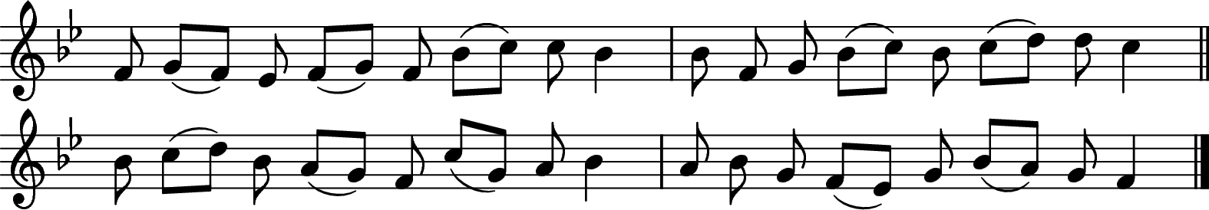

Bishop Come, Holy Ghost, our souls inspire,
All And lighten with celestial fire;
Thou the anointing Spirit art,
Who dost thy sevenfold gifts impart:

Thy blessèd unction from above
Is comfort, life, and fire of love;
Enable with perpetual light
The dullness of our blinded sight:

Anoint and cheer our soilèd face
With the abundance of thy grace:
Keep far our foes, give peace at home;
Where thou art guide no ill can come.

Teach us to know the Father, Son,
And thee, of Both, to be but One;
That through the ages all along
This may be our endless song,

Praise to thy eternal merit,
Father, Son, and Holy Spirit. Amen.

Veni Creator (Mechlin) (138) ~ Mode viii John Cosin (1594 – 1672)
based on Veni, creator Spiritus

Litany
led by Assistant Diocesan Directors of Ordinands

In the power of the Spirit and in union with Christ,
let us pray to the Father.
All Lord, have mercy.

For the peace of the whole world,
for the welfare of the Holy Church of God, and for the unity of all,
let us pray to the Lord.
All Lord, have mercy.

For all the members of the Church in their vocation and ministry,
that they may serve him in truth and love,
let us pray to the Lord.
All Lord, have mercy.

For Jonathan our bishop,
Simon, Bishop of Tonbridge,
and for all bishops, presbyters and deacons,
that they may hunger for truth and thirst after righteousness,
let us pray to the Lord.
All Lord, have mercy.

For those called to be priests in the Church,
let us pray to the Lord.
All Lord, have mercy.

For the mission of the Church, that in faithful witness we may proclaim the gospel of reconciliation to the ends of the earth,
let us pray to the Lord.
All Lord, have mercy.

For the unity of the Church, that we may be one in Christ,
according to his will,
let us pray to the Lord.
All Lord, have mercy.

For those who do not yet believe, that they may receive the light of the gospel, and for those whose faith has grown cold,
let us pray to the Lord.
All Lord, have mercy.

For the sick and suffering, for the aged and infirm, for the lonely and neglected, and for all who remember and care for them,
let us pray to the Lord.
All Lord, have mercy.

For the poor and the hungry, for the homeless and the oppressed,
for all prisoners and captives, and for our brothers and sisters
who are persecuted for their faith,
let us pray to the Lord.
All Lord, have mercy.

For Charles our King, for the leaders of the nations,
and for all in authority,
let us pray to the Lord.
All Lord, have mercy.

For ourselves, for grace to repent and amend our lives,
that we may be pardoned and absolved from all our sins,
let us pray to the Lord.
All Lord, have mercy.

Remembering all who have gone before us in faith,
and in communion with all the saints, we commit ourselves,
one another, and our whole life to Christ our God;
All To you, O Lord.

The Ordination Prayer

The Bishop stands to pray

Bishop We praise and glorify you, almighty Father,
because in your infinite love you have formed throughout the world
a holy people for your own possession,
a royal priesthood, a universal Church.

We praise and glorify you
because you have given us your only Son Jesus Christ,
the image of your eternal and invisible glory,
the firstborn of all creation and head of the Church.

We praise and glorify you that by his death he has overcome death;
and that, having ascended into heaven,
he has given his gifts abundantly,
to equip your holy people for the work of ministry,
for the building up of the body of Christ.

And now we give you thanks
that you have called these your servants,
whom we ordain in your name,
to share as priests in the ministry of the gospel of Christ,
the Apostle and High Priest of our faith,
and the Shepherd of our souls.

Therefore, Father, through Christ our Lord we pray:

Supporters are invited to stand when their Ordinand stands before the Bishop

Here the Bishop and priests lay their hands on the head of each Ordinand, and the Bishop says

Send down the Holy Spirit on your servant …
for the office and work of a priest in your Church.

When the Bishop has laid hands on all of the Ordinands, the prayer continues

Through your Spirit, heavenly Father,
give these your servants grace and power
to proclaim the gospel of your salvation
and minister the sacraments of the new covenant.
Renew them in holiness,
and give them wisdom and discipline
to work faithfully with those committed to their charge.

In union with their fellow servants in Christ,
may they reconcile what is divided,
heal what is wounded
and restore what is lost.

May they declare your blessings to your people;
may they proclaim Christ’s victory over the powers of darkness,
and absolve in Christ’s name those who turn to him in faith;
so shall a people made whole in Christ
offer spiritual sacrifices acceptable to you,
our God and Father,
to whom, with the Son and the Holy Spirit,
belong glory and honour, worship and praise, now and for ever.
All Amen.

The Anointing

During the anointing, the choir sings
³ Worldly joys, like shadows fade
When the heavenly light appears;
But the covenants thou hast made,
Endless, know nor days, nor years.

⁴ In thy word, Lord, is my trust,
To thy mercies fast I fly;
Though I am but clay and dust,
Yet thy grace can lift me high.

¹ View me, Lord, a work of thine:
Shall I then lie drowned in night?
Might thy grace in me but shine,
I should seem made all of light.

² Cleanse me, Lord, that I may kneel
At thine altar, pure and white;
They that once thy mercies feel,
Gaze no more on earth’s delight.

Richard Lloyd (b.1933) Thomas Campion (1567-1620)

The Bishop anoints the palms of each newly ordained priest with the oil of chrism, saying
May God, who anointed the Christ with the Holy Spirit at his baptism,
anoint and empower you to reconcile and bless his people.

The Bishop presents each newly ordained priest with an oil stock to use in the healing, restoring and sanctifying ministry of Christ, the Anointed One.

The new priests are assisted to vest their stole priest-wise

The Welcome

All stand

The Dean says to the newly ordained priests

God was in Christ,
reconciling the world to himself,
and has given us the ministry of reconciliation.

All We welcome you as ambassadors for Christ:
let the word of Christ dwell in you richly.

The newly ordained priests are welcomed with applause

The Liturgy of the Eucharist

Stand

The Peace

Bishop God has made us one in Christ.
He has set his seal upon us,
and as a pledge of what is to come
has given us the Spirit to dwell in our hearts.

The peace of the Lord be always with you
All and also with you.

Deacon Let us offer one another a sign of peace.
Preparation of the Table

Taking of the Bread and Wine

Offertory Hymn
during which a collection is taken

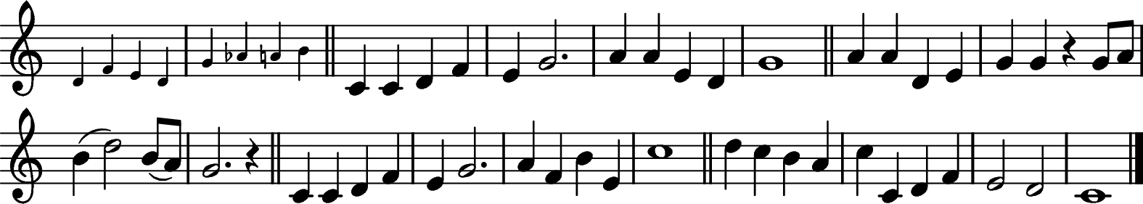
⁴ Bore it up triumphant
With its human light,
Through all ranks of creatures,
To the central height,
To the throne of Godhead,
To the Father’s breast;
Filled it with the glory
Of that perfect rest.

⁵ In your hearts enthrone him;
There let him subdue
All that is not holy,
All that is not true:
He is God the Saviour,
He is Christ the Lord,
Ever to be worshipped,
Trusted, and adored.

⁶ Truly, this Lord Jesus
Shall return again,
With the Father’s glory,
With his angel train;
For all wreaths of empire
Meet upon his brow,
And our hearts confess him
King of glory now.
¹ At the name of Jesus
Every knee shall bow,
Every tongue confess him
King of glory now;
‘Tis the Father’s pleasure
We should call him Lord,
Who from the beginning
Was the mighty Word.

² At his voice creation
Sprang at once to sight,
All the angel faces,
All the hosts of light,
Thrones and dominations,
Stars upon their way,
All the heavenly orders,
In their great array.

³ Humbled for a season,
To receive a name
From the lips of sinners
Unto whom he came,
Faithfully he bore it
Spotless to the last,
Brought it back victorious
When from death he passed:

Camberwell (AM 593i) ~ John Michael Brierley (b. 1932) Caroline Maria Noel (1817-1877)

The Bishop takes the bread and wine

Bishop Heavenly Father,
as we set before you these gifts of bread and wine,
bless also the gift of our hearts and minds
as we offer our lives in your service;
for Jesus Christ’s sake.
All Amen.

Eucharistic Prayer E

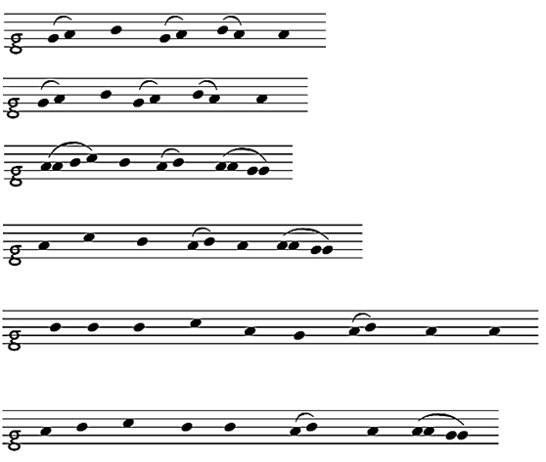
President The Lord be with you.

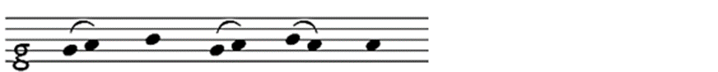
All and al – so with you.

President Lift up your hearts.

All We lift them to the Lord.

President Let us give thanks to the Lord our God.

All It is right to give thanks and praise.

Bishop It is indeed right and good,
our duty and our salvation,
always and everywhere to give you thanks and praise
through your Son Jesus Christ, our great high priest.

He was lifted up for us on the cross
that he might reveal your glory and draw all people to himself.
You exalted him to your right hand on high
and through your Holy Spirit you sent upon your people
a rich diversity of gifts.

From this royal priestly people you raise up ministers
to proclaim your word,
to care for your people
and to be the stewards of your holy mysteries.
You call them to serve the world your Son redeemed
and build up his body the Church to be his bride.

Therefore with angels and archangels,
and with all the company of heaven,
we proclaim your great and glorious name,
for ever praising you and singing:

Choir Holy, holy, holy, Lord God of hosts,
Heaven and earth are full of thy glory.
Glory be to thee, O Lord most high.
Blessed is he that cometh in the name of the Lord.
Hosanna in the highest.

Charles Villiers Stanford (1852-1924) Communion Service in B-flat

Bishop We praise and bless you, loving Father,
through Jesus Christ, our Lord;
and as we obey his command,
send your Holy Spirit,
that broken bread and wine outpoured
may be for us the body and blood of your dear Son.

On the night before he died he had supper with his friends
and, taking bread, he praised you.
He broke the bread, gave it to them and said:
Take, eat; this is my body which is given for you;
do this in remembrance of me.

When supper was ended he took the cup of wine.
Again he praised you, gave it to them and said:
Drink this, all of you;
this is my blood of the new covenant,
which is shed for you and for many for the forgiveness of sins.
Do this, as often as you drink it, in remembrance of me.

So, Father, we remember all that Jesus did,
in him we plead with confidence his sacrifice
made once for all upon the cross.
Bringing before you the bread of life and cup of salvation,
we proclaim his death and resurrection
until he comes in glory.

Deacon Great is the mystery of faith.
All Christ has died:
Christ is risen:
Christ will come again.

Bishop Lord of all life,
help us to work together for that day
when your kingdom comes
and justice and mercy will be seen in all the earth.

Look with favour on your people,
gather us in your loving arms
and bring us with the Blessed Virgin Mary
and all the saints
to feast at your table in heaven.

Through Christ, and with Christ, and in Christ,
in the unity of the Holy Spirit,
all honour and glory are yours, O loving Father,
for ever and ever.
All Amen.

Kneel or sit

The Lord’s Prayer

Bishop As our Saviour taught us, so we pray
All Our Father in heaven,
hallowed be your name,
your kingdom come,
your will be done,
on earth as in heaven.
Give us today our daily bread.
Forgive us our sins,
as we forgive those who sin against us.
Lead us not into temptation,
but deliver us from evil.
For the kingdom, the power
and the glory are yours
now and for ever.
Amen.

Breaking of the Bread

Bishop We break this bread
to share in the body of Christ.
All Though we are many, we are one body,
because we all share in one bread.

Giving of Communion

Bishop Jesus is the Lamb of God
who takes away the sin of the world.
Blessed are those who are called to his supper.
All Lord, I am not worthy to receive you,
but only say the word, and I shall be healed.

Choir O Lamb of God.
that takest away the sins of the world,
have mercy upon us / grant us thy peace.

Charles Villiers Stanford (1852-1924) Communion Service in B-flat

All who are regular communicants in their own churches are welcome to receive communion here. Gluten-free hosts are available: please ask the stewards and come to the stations at the front of the Nave. If you wish to come for a blessing instead of receiving communion, please carry this service paper with you as a sign to the minister. We keep a prayerful silence to allow others to prepare to receive communion or pray afterwards. Please follow the directions of the stewards.

Anthem

Come down, O love divine, seek thou this soul of mine,
And visit it with thine own ardor glowing.
O Comforter, draw near, within my heart appear,
And kindle it, Thy holy flame bestowing.

O let it freely burn, til earthly passions turn
To dust and ashes in its heat consuming;
And let Thy glorious light shine ever on my sight,
And clothe me round, the while my path illuming.

Let holy charity mine outward vesture be,
And lowliness become mine inner clothing;
True lowliness of heart, which takes the humbler part,
And o’er its own shortcomings weeps with loathing.

And so the yearning strong, with which the soul will long,
Shall far outpass the power of human telling;
For none can guess its grace, till he become the place
Wherein the Holy Spirit makes a dwelling.

William Harris (1883-1973) Bianco da Siena (d 1434)
Tr. R.F. Littledale (1833-1890)

Hymn

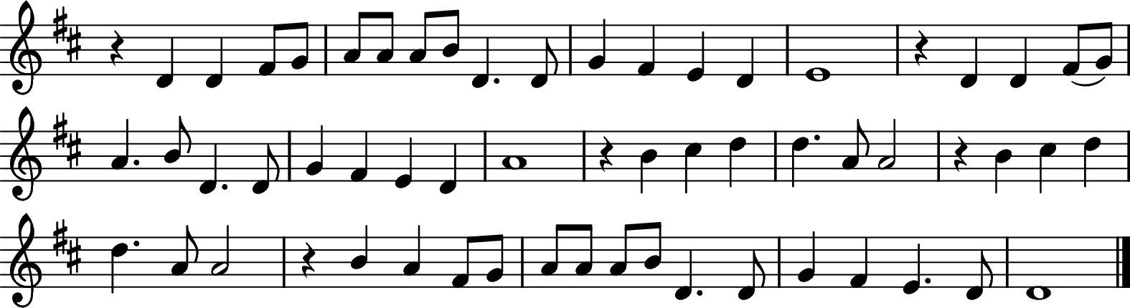

Be still, for the presence of the Lord, the Holy One, is here.
Come, bow before him now, with reverence and fear.
In him no sin is found, we stand on holy ground.
Be still, for the presence of the Lord, the Holy One, is here.

Be still, for the glory of the Lord is shining all around;
He burns with holy fire, with splendour he is crowned.
How awesome is the sight, our radiant King of light!
Be still, for the glory of the Lord is shining all around.

Be still, for the power of the Lord is moving in this place,
He comes to cleanse and heal, to minister his grace.
No work too hard for him, in faith receive from him;
Be still, for the power of the Lord is moving in this place.

Be still NEP (629) David J Evans (b. 1957)

Prayer after Communion

Bishop Let us pray.

Stand

Bishop Lord God, heavenly Father,
grant to your Church today the faith of her apostles,
the hope of her martyrs and the love of her Lord,
our Saviour Jesus Christ.
All Amen.

All We thank you, gracious Father,
for welcoming your children to feast in your kingdom;
by your love unite us
and with your Spirit send us,
Hymn
during which the Bishop gives the Bible to each of the newly ordained priests

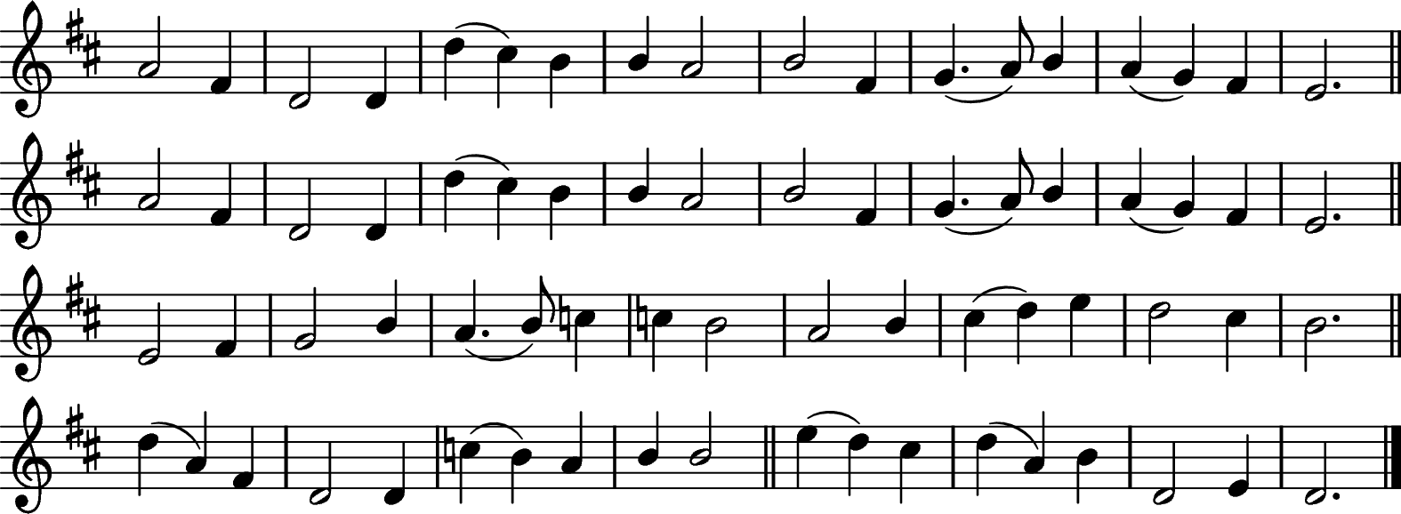

Lord, you give the great commission:
'Heal the sick and preach the word'.
Lest the Church neglect its mission,
And the gospel go unheard,
Help us witness to your purpose
With renewed integrity;
With the Spirit's gifts empower us
For the work of ministry.

Lord, you call us to your service:
'In my name baptize and teach'.
That the world may trust your promise,
Life abundant meant for each,
Give us all new fervour, draw us
Closer in community;
With the Spirit's gifts empower us
For the work of ministry.

Lord, you make the common holy:
'This my body, this my blood'.
Let us all, for earth's true glory,
Daily lift life heavenward,
Asking that the world around us
Share your children's liberty;
With the Spirit's gifts empower us
For the work of ministry.

Lord, you show us love's true measure;
'Father, what they do, forgive'.
Yet we hoard as private treasure
All that you so freely give.
May your care and mercy lead us
To a just society;
With the Spirit's gifts empower us
For the work of ministry.

Lord, you bless with words assuring:
'I am with you to the end'.
Faith and hope and love restoring,
May we serve as you intend,
And, amid the cares that claim us,
Hold in mind eternity;
With the Spirit's gifts empower us
For the work of ministry.

Abbot’s Leigh (499) ~ Charles Hubert Hastings Parry (1848-1918) Jeffrey W Rowthorn (b 1934)

The Sending Out

The Giving of the Bible

Bishop Receive this book,
as a sign of the authority
which God has given you this day
to preach the gospel of Christ
and to minister his holy sacraments.

Blessing and Dismissal

Bishop Our help is in the name of the Lord,
All who has made heaven and earth.

Blessed be the name of the Lord,
All now and forever. Amen.

God who has called you is faithful.

May the Father, whose glory fills the heavens,
cleanse you by his holiness
and send you to proclaim his word.
All Amen.

May Christ, who has ascended to the heights,
pour upon you the riches of his grace.
All Amen.

May the Holy Spirit, the comforter,
equip you and strengthen you in your ministry.
All Amen.

And the blessing of God almighty,
the Father, the Son and the Holy Spirit,
be among you and remain with you always.
All Amen.

Deacon Go in the peace of Christ.
All Thanks be to God.

The Bishop leads the newly ordained priests to the Great West Door and the other ministers exit in procession.

Organ Voluntary

