Children’s, Youth and Family Bibles

Date August 2022
There are many Bibles available for children, young people and families. These are all good for sharing the Bible either within a group setting or for children & young people to use at home. We have copies of most of these in the Diocesan office so please have a chat with your CYP team and have a look before you make a decision.

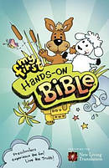
My First Hands-On Bible is the pre-schooler version of the popular Hands-On Bible. My First Hands-On Bible uses experience-based learning to communicate God's Word in an active, understandable way. My First Hands-On Bible is a fun, simple and meaningful way to engage preschool and KS1children (ages 3-6) with the Bible while helping them build a solid faith foundation. Each lesson focuses on a specific Bible point through a variety of activities to reinforce and help young children remember the stories and lessons. Using common household items, you can help your children have a hands-on learning experience while engaging them in 85 key stories from the Bible. It also includes actual Scripture from the easy-to-understand and easy-to-read New Living Translation. In addition to the stories and activities, there are fun illustrations, prayers, and a special Jesus Connection feature.

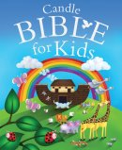
The Candle Bible for Kids
For ages 5-7
There are 400 pages of approximately 50 engaging bible stories that will leave kids awe-struck by God's wonderful presence.
The stories are written in a style suitable for 5-7 year olds and each are roughly 8 pages long. The stories contain numerous scripture references and are also accompanied by vibrant illustrations.

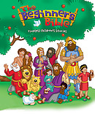
The Beginners Bible
For children aged 2-5. This is made to be a Child's first Bible by using simple text and bright images.
The author wanted to create a book that told the incredible stories of the Bible in a child-friendly writing style. This new, revised edition of Karyn Henley's book includes: 94 timeless Bible stories, fresh new art and bright and colourful illustrations.

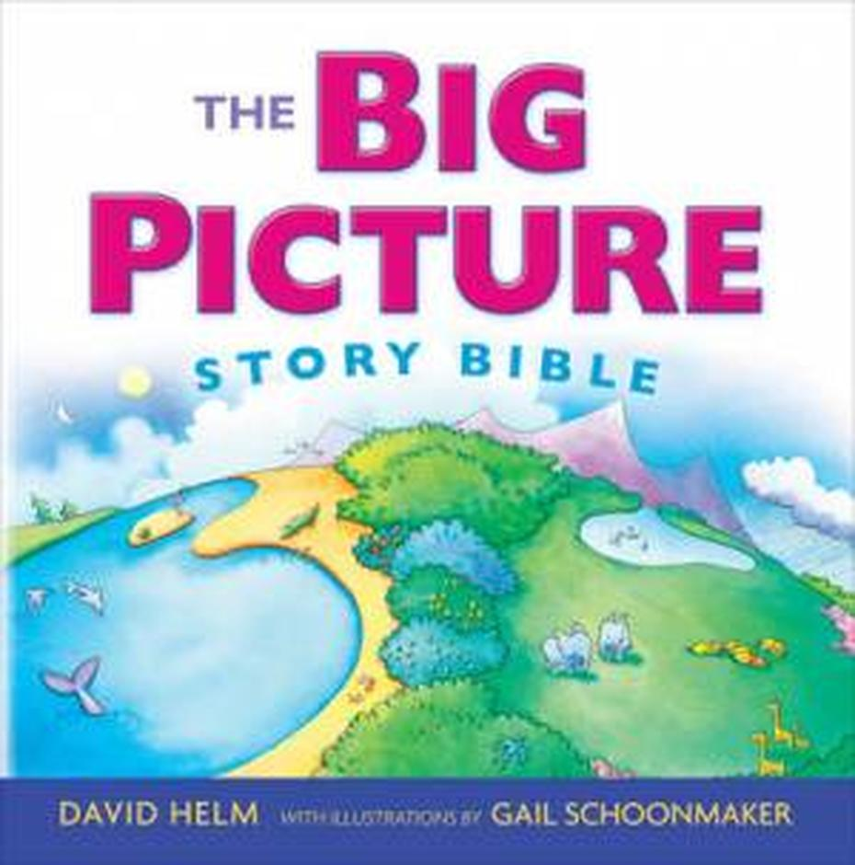
The Big Picture Story Bible a colourful book of Bible stories written especially for children ages 2–7. This book presents the big picture, the unified story running through the Old and New Testaments. Twenty–six stories together form parts of this big picture.
This teaches children the Bible’s whole story so they can begin to appreciate the fulfilment of God’s promise to his people. Perfect for parents to read to their children and for older children to read on their own.

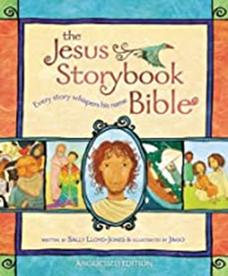
The Jesus Storybook Bible
The multiple award winning Jesus Storybook Bible tells the story beneath all the stories in the Bible.
Written by Sally Lloyd Jones and illustrated by Jago, The Jesus Storybook Bible tells the Bible narrative and shows where ‘every story whispers His name’ so connecting Jesus to the whole ark of God’s Story. It invites children to discover for themselves that Jesus is at the centre of God's great story of salvation and at the centre of their story, too.

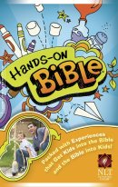
The Hands-on Bible
The bright colourful cover invites you to look deeper into this New Living Translation of the Bible packed with extras such as Bible Bios, Fun facts, and all sorts of activity suggestions, all aimed at making Bible reading fun and informative. The chapter headings make for ease of finding the part you are looking for. I spent ages reading through the many inserts, all with their bible references.
This would make an excellent Bible for an older child or young teen.

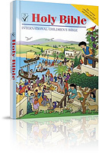
The International Children's Bible gives you an authentic Bible translated from the original texts specifically for children aged 6 to 12. Unlike many 'children's Bibles' this is not an adult Bible repackaged for children. Written with British English spellings and grammar, it is a new translation that uses words and phrases the children use and understand in English that can be read and the meaning grasped by children reading for themselves.
It has simple, direct language and plainly constructed sentences. Laid out in large easy-to-read type and in two columns - which means shorter, easy to follow lines. It has a simple, modern vocabulary together with over 40 pages of maps, illustrations and a dictionary.

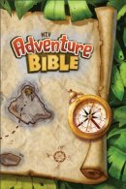
My Adventure Bible
Embark on a fun, exciting journey through God's Word with the Adventure Bible. Along the way you'll meet all types of people, see all sorts of places, and learn all kinds of things about the Bible. Most importantly you'll grow closer in your relationship with God. This edition uses the full Bible text from the revised and updated NIV. There's lots of additional material including articles on life in Bible times, people of the Bible, book introductions, illustrations, verses to highlight and hands-on activities. Twenty colour pages with games and other Bible fun and colour maps.

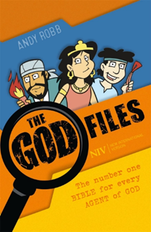
The God Files NIV Bible This Bible has each book styled as a ‘file’. It will invite children into the story of Scripture by encouraging them to play their part as agents with a mission, inspired by the adventures and impact of the special agents they read about, such as Joseph, David, Esther and Mary. There are Agent Profiles, as well as extra content to help children explore faith, learn about God and to start them off on a lifetime of Bible reading. Each book of the Bible has an introduction that informs agents of the key facts about the file, such as ‘Where the action happened’, and ‘Agents to look out for’. In each book, there are encoded verses to decipher, jokes, ‘Undercover Investigations’, ‘Fascinating Facts’, ‘Agent Essentials’ etc.
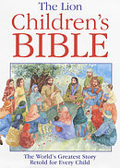
The Lion Children's Bible is a collection of the world's greatest Bible stories retold for children.
The most significant stories from the Old and New Testaments to the book of Acts are retold in a clear, simple, and engaging way. The language, pictures, and style will all resonate in the mind of a child. The stories can be read a by themselves, but when linked together they form a beautiful narrative about the 'one story' of God and his people contained in the whole Bible.

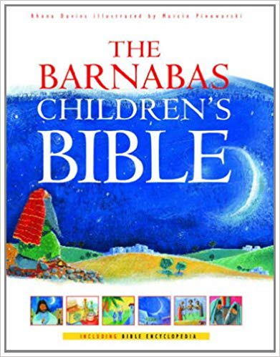
The Barnabas Children's Bible presents a continuous thread from Genesis to Revelation in chronological rather than biblical, order. With stylish illustrations, here there are retellings of familiar and less well-known Bible passages. The 365 stories could be used as daily readings or as a dip-in read, providing an ideal transition from a book of Bible stories to the text and layout of an adult Bible. Each story has a Bible quotation from the CEV, encapsulating a truth from the story. Children can familiarize themselves with the wealth of literature in the Bible using the full contents of stories or the useful indexes of people and famous passages. There is also an encyclopaedia of background information on topics including civilisations, food, towns religious practices, and daily life.

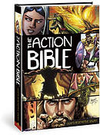
The Action Bible is an exciting full colour comic-book style picture Bible for children ages 10-14, though younger children -say down to 8 years old, will also enjoy it.
This fast moving storified Bible presents 215 all new, fast-paced narratives drawn in chronological order to make it easy to follow the Bible's historical flow and reinforces the build-up to a thrilling climax. Altogether, this is the most complete picture Bible ever featuring captivating, up-to-date artwork with a comic book style making it the perfect Bible for today's young readers used to receiving their information mostly as a visual experience.
The stories in The Action Bible clearly and forcefully communicate with today's contemporary readers. This compelling mix of clear type face plus dramatic, colourful images offers an appeal that crosses all age boundaries.

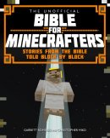
Bible for Minecrafters
Very popular with children who will love this new world and the adventures of God's people. The writers have re-created Bible stories with the famous virtual blocks to produce vibrant, and complex 3-D worlds filled with adventure and imagination.
The images have been captured and combined with text boxes and speech bubbles to explain the stories for 7-11 year olds.

The Lion Graphic Bible
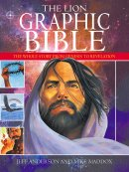
Beautifully illustrated and makes great use of bright vivid colours as well as remaining true to the story of the Bible. In 752 large pages, it covers many parts of the Old and New Testament; with more content than most comic book Bibles. The Bible is a unique narrative of origins and cosmic powers; of the ageless battle between good and evil; of human potential and human treachery - the very stuff that graphic novels are made of.
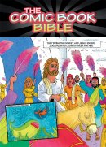
The Comic Book Bible
Updated and repackaged with a great new cover, The Comic Book Bible is filled with clever, comic-style illustrations that bring Bible stories to life. Kids ages 8 to 12 won't be able to stop reading this Bible that will plant seeds of interest in reading and studying God's Word. A picture-perfect beginning to a never-ending faith journey!

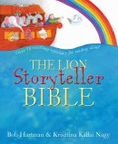
The Lion Storyteller Bible broke new ground in its presentation - both verbal and visual - of Bible stories. It has been immensely popular, with sales in the UK exceeding 130,000 copies and editions printed in more than 11 languages. Since The Lion Storyteller Bible was first published Bob Hartman has established an international reputation as a storyteller and writer.
This new book integrates more than 20 new Bible story retellings with the 50 tried and tested originals. It also includes a useful appendix of Bob Hartman's hints and tips for storytelling. Newly commissioned illustrations throughout will capture as much warmth and appeal as those in the first edition.
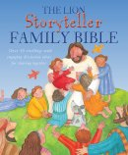
The Lion Storyteller Family Bible with over 40 stories with interactive elements alongside to encourage the whole family to think, discuss and make connections with their lives. Aimed to spark discussion about faith and trusting God and looking for Him in the everyday. Has prayer prompts to help make time to talk and listen to God.

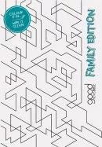
The Good News Family Bible in partnership with Youth for Christ, and other family focused organisations – this family edition of the GNB has been created with the heart of putting the Bible back at the centre of family life. Along with a reusable ‘whiteboard’ cover and supportive YouTube content, this Bible features ways to help families of all shapes and sizes experience the Bible together. Including landscape page layout to encourages family engagement around the Bible as well as over 400 interactions throughout, based on the themes of Think, Chat, Do, Create and Watch. There is space inside for writing, doodling and drawing as well as 26 online videos that help guide, support and unpack the tricky bits as you journey through the Bible

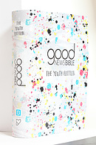
GNB Youth Bible How do you make a youth Bible that speaks to teenagers? One that answers the questions they have, speaks to issues they face, and is presented in a way that appeals to them? Simple. You don’t just make it for them. You make it with them.
The Good News Youth Bible is made through a partnership between the Bible Society and Youth For Christ. Helping young people connect the Bible with their lives, the GNB Youth Bible was put together with the assistance of young Christians. They shared ideas, told what matters to them, and gave ways that a Bible could be made that would encourage them to read it more. And they were heard.
This GNB Youth Bible features a journaling element. Whether it’s through drawing, writing, colouring and other ways of creative engagement, this Bible lets young people express themselves in response to the text. There are wide margins, spaces to doodle, and fill in. The GNB Youth Bible also features questions and prompts with space for answers. And these are on every page of the Bible.There are also an abundance of extras that help open up what the Bible is saying in a clear way.
Engage Youth Bible has a well-designed, attractive cover, is produced in solid hardback, and features a yellow elastic ‘hold-all’.
Inside, the text is a good size, easy to read NIV translation, with wide margins for note-taking, doodling, prayer ideas and large Bible verses designed for colouring, and there are journal ideas.
A helpful feature is the ‘Big Bible Story Reading Plan’ – a 21-day Bible reading guide which takes teens through the big story of the Bible. For each passage there is a reflection, some questions and prayer ideas.
In addition, there are helpful tips on how to read the Bible, articles on all kinds of issues such as the environment, self-harm and sexuality, apologetics-type questions, and ‘real lives’, featuring persecuted Christians, slavery and missionary life.
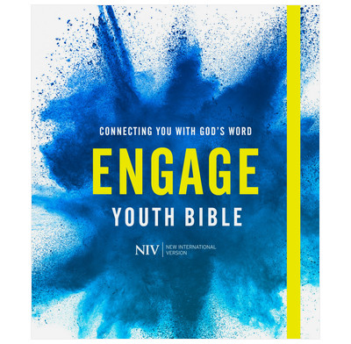
https://www.thegoodbook.co.uk/engage-niv-youth-bible
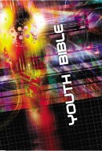
NCV Youth Bible in sunburst hardback for young Bible readers aged 14 to 18 years
The NCV (New Century Version) Youth Bible is a directly relevant modern English translation Bible. Plus, over 470 real life stories and hundreds of background Bible facts designed to connect with the hearts and minds of teenagers. There are more than 50 maps and diagrams throughout the NCV Bible text to explain how, where, when and why all the world-changing events in the Bible took place. Reasons to buy and give the best selling NCV Youth Bible:

In 2020 this blog looked at favourite Bibles; helpful to look at
https://thehopefilledfamily.com/what-is-the-best-childrens-bible/

