Children’s Faith Resources

October 2022

These organisations produce specific material that can be used around their resources. You can of course use the videos for the basis of the teaching and build your own lesson plan around it. Please be careful regarding sending videos or their printed material electronically – you will need to check permissions and licences – they are all different!
If you send a link to an online video however and build your own lesson plan you are not breaking any licensing laws.

Superbook:

A series of video’s of 2 modern children and a robot going back in time to meet the Biblical characters. When you subscribe, you gain instant access to the full multi-year Superbook Academy curriculum and complete resource library. Teachers can plan and present lessons, and stream videos directly from any connected device. Lessons can also be printed. Print out as many crafts as you need, and show the videos as often as you want.
This is the paid for version however some of the videos are available on Youtube and you could put resources together to accompany each video. There is also an App for the kids to use.



Friends And Heroes
www.friendsandheroes.com.uk
A set of cartoons about Roman children and they hear the stories from the Bible. You can purchase DVD’s at £12 for 2 episodes or a series for £70. You can buy an organisation pack for £120 which is a combination of the Family and Licence and Lessons Packs and is ideal for those wanting to show Friends and Heroes DVDs in a group situation as you will be issued with a Public Display Licence Certificate for the series (for either your premises or a named presenter) and given permanent access to the School Lessons. There is a puzzle/colouring book available for each series.
Currently with their organisation packs (and therefore the public display licence) they are providing links which can be emailed out to church families along with a lesson and other relevant material. This will continue until children’s ministry can return to the buildings.
A few episodes are available on Youtube.

Story Keepers :
http://www.storykeepersedu.com/webresources.html
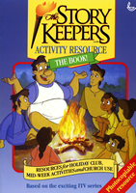
These are a series of cartoons about Christian children in Rome who hear the stories of Jesus whilst having adventures.
The DVDs are available as a set (and we have 30 sets which we are happy to lend out) as well as being available to watch on Youtube. Each episode has 2 or 3 Bible stories in which you could prepare/ use other material with. There is a Leaders pack containing all 13 episodes on 2 DVDs and includes Scripture Union's Storykeepers Leaders Activity Resource handbook written by John Stephenson which is a photocopiable resource. It covers 5 specific episodes in great detail but also offers a multitude of ideas, games, songs etc to help any church leader.
Suitable for general holiday club, Lent/Easter course (last 4 episodes) or for illustrative assistance with Jesus’s parables. The DVDs allow teachers & leaders direct access to each of 47 parables and stories in the series
Price £39.95. Activity Resource Handbook is also sold separately price £12.00
Also they produce Come with Marcus – a Gospel of Mark (with added extras) that has QR codes on the stories. Click the code and watch the episode on a smartphone (47) in all. Each book is £3 or £2.50 (depending on quantity). Then build session around the story, using the Handbook if desired. We have a sample of the book – looks like a really useful resource. The suggestion is to fund a copy for the year 2 children in a local school. This can then be followed up with a family party lasting an hour to an hour and a half around different themes such as Easter, Christmas etc. There is a book of party plans available as a good starting place.
if you have questions, please email Ross Coad at ross@comewithmarcus.com - and include your phone number.

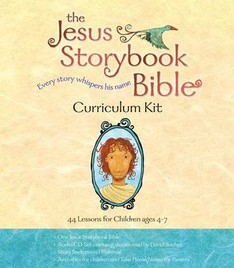
Jesus Storybook Bible
There is the Bible itself which tells the whole of underlying Bible story and there is a set of 4 DVDs narrating the book. Many of these stories are available on Youtube.
There is also a Curriculum kit containing 44 individual lesson plans plus 6 review lessons (3 Old Testament, 3 New Testament – available online) plus ideas for engaging activities, easy-to-use instructions and notes for teachers based on material from Timothy Keller, memory verses, colour handouts, and more.
If you wish to electronically distribute their material, you do need to ask permission.

Saddleback Ministries
Saddleback Kids on Youtube have excellent short videos of Bible stories.
Their website www.saddleback.com also has resources for families to access. There is a video that includes worship songs, animated Bible stories, teachings, and explanations of the Bible story. Also has Talk It Over Questions which will include conversations about the Bible story to allow families and children to reflect on the biblical truth and share their thoughts about the video with each other. It is also possible to download more tools, resources, and activities to go along with the video including colouring pages, craft or activity sheets, games, additional questions and ideas to engage with the Bible story further at home with their child.
Good Good Father
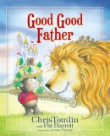
This is a lovely book, written by the song’s creator. It tells children what God is like. I used this book (gave a copy to each family) and looked at one aspect of God in each session and found a Bible story to illustrate that aspect.
I found it worked very well as the children re read the book weekly and benefited from the Bible teaching that went with it.
Other books may work just as well, I just know from experience that this was very well received.

The Dig for Kids
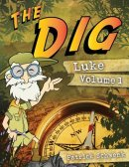
is a simple and easy way for parents to study through books of the Bible with their children. The Dig takes the guesswork out of teaching for parents. Each lesson is just one page that contains four main parts:
The Map - The Map is the overview of each lesson. It will tell you as a parent and your child what you will be looking at.
The Dig - The Dig is the main passage of the Bible to read. There are typically three or four review questions that will help with discussion and review.
The Treasure - The Treasure is the big idea of the passage you have just thought about. Simply put, it is what you want your child to remember in one sentence.
The Display - Archaeologists go on a dig, find a treasure, and then put it on display for all to see. This is the basic idea behind the Display. It helps your child live out what he or she has just learned.
Early on in The Dig you will meet a character named Doc. He will be your expert and experienced tour guide. Through each Dig, Doc will help guide a child systematically through books of the Bible. The Dig for Kids is a great resource for parents because it makes teaching children the Bible simple, fun, and interactive!
www.thedigforkids.com!
Together at Home
Together at Home produce weekly for both lectionary and non-lectionary, for families to work through together. They have also produced resources to be used through different seasons. They are ideal with little bitesize activities which can be used at the families own pace.
https://www.tath.co.uk/
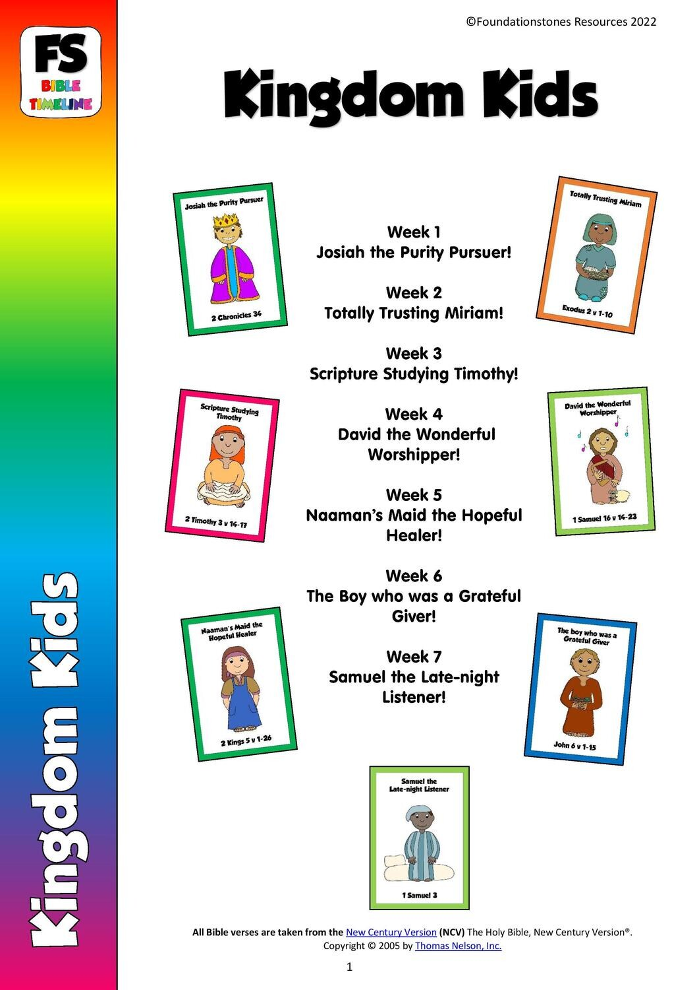
Foundationstones Resources. (by the creator of t.at h. resources) Have created a resource for Sunday Clubs which is Biblical, flexible and spirit filled. Their vision is to see adults and children united in praying, serving and learning more about God by equipping churches to equip their children!
​The range of Sunday School Materials are all designed to be used alongside a Bible Timeline so that children get a real understanding of where the stories they are studying fit in God's Big Plan. Each week contains a story, discussion, craft, game and an activity to connect with Holy Spirit as well as a Faith at Home sheet for families to use.
The regular materials work out at around £5 a month. You will be able to purchase a whole year’s worth of curriculum for under £100 and those who ask for financial support will be able to access discounts of up to 25%.
Some of their resources also come with Intergenerational worship resources and small group adult Bible study materials.
https://www.foundationstones.co.uk/

Faith In Kids.org
Is a website with resources for children’s ministry aimed at seeing more children engaging with and responding to God personally rather than growing up simply knowing Bible facts and a long list of Christian behaviours.
Faith in Kids focuses on those who lead the children’s ministry in their local Church. Wanting to build their confidence and grow their vision to see how vital their role is. These key individuals, in turn, can then be a catalyst for change in countless children’s lives through Sunday School leaders, parents and church leaders. They also encourage and equip parents to open the Bible and speak about faith in Christ with their children at home.
There is material for use in a church setting as well as in the home.

Grow Curriculum.
This is part of Stuff You Can Use. They offer a year’s youth and children’s ministry curriculum. It is from the US. They do have free resources for you to try and then there is a subscription. The free stuff is worth looking at and using if you like it.
https://stuffyoucanuse.org/

God Venture
Resources for families to explore faith at home. https://godventure.co.uk/shop/

Church OF England Faith @ Home
These are videos put together for families, around a different topic every week. There is an equivalent resource for schools too. The family can watch the video together, it contains voices of young people, as well as a story, some questions to think about and a prayer/ craft idea to do together. Very simple but effective.
www.churchofengland.org/faith-action/faith-home/i-am-parent

Urban Saints
A widely used resource which is searchable. They offer a free trial. The cost is then approx £20 / month.
One Energize subscription enables you to access high-quality, age-appropriate, Bible-based resources for every stage of a young person's development. Energize will equip you to understand, engage with and respond to their needs, from ages 3 to 15+.

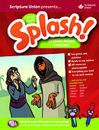
Scripture Union
Their Light Material as well as Guardians of Ancora are available under the resources section of their website. There is a search bar to help locate what you need. The books covering a whole year’s Light resources are also available. The group materials are also available to download. There is material from pre-school to 11-14’s.

Sermons4kids.com
An American resource with both free resources, a 14 day trial of the ‘Plus’ version and the paid for syllabus. Plenty of free worksheets and session ideas.

Ministry-to-children.com provide age-appropriate Bible study material and Sunday School curriculum for free.
Sunday School Store is connected to Ministry to Children but has a cost attached so they can provide high quality resources. https://sundayschool.store/

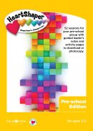
HeartShaper®
Children’s Curriculum is designed to help children in your Sunday group or activity club discover God through His Word. Each session will take your group through the Bible and its key themes, encouraging a life-long love of Scripture and helping children to see how God can shape their lives.
There is a Primary age edition, aimed at ages 5 to 11 as well as one for 3-5’s with fifty-two sessions for your Sunday school or children’s activity group with guided leader’s notes and reproducible activity pages. Each session’s leader’s guide comes with four clear steps to guide you (Focus In, Explore His Word, Make It Real, and Live It Out) and are flexible enough to match the length of your session. These are complemented with reproducible activity pages, including special needs friendly resources to ensure every child is included and made to feel welcome.

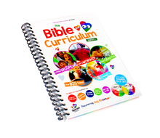
Little Worship Company
The Bible Curriculum Series is a comprehensive and versatile 'Sunday School in a box' solution for churches, toddler and play groups. This resource includes a book, containing over 32 weeks of lesson plans and a series of four accompanying DVD’s. It is available on line. They also publish a Devotional book for families to use at home, DVD’s are available to supplement the book.
There is also an app Little Worship Company World . Again aimed at pre-schoolers and their families. There is a 14 day free trial available.
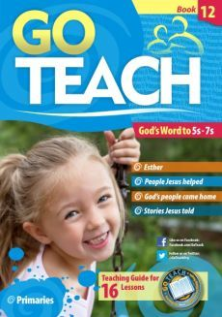
Go Teach resources are aimed at children and young people in Sunday School, church, club, home and school.
It take the Bible seriously as the Word of God, and apply it to today's youngsters, with a comprehensive programme, covering the major events, people, and doctrines of the Bible. It is thoroughly Bible-centred and non-denominational.

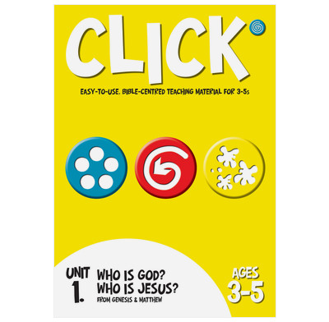
Click is a Bible-based programme for teaching and discipling children from 3-11 years. The CLICK curriculum is based on the belief that the Bible’s own theological framework should direct what is taught and how it is taught. CLICK is Bible-based, teaching the major events, concepts and doctrines of the Bible. Each book includes 10 sessions each with engaging and purposeful activities, games and crafts, music suggestions, extension ideas for more able children, photocopiable masters for visual aids and activities.
God’s Big Story
Bible stories are made accessible and memorable for under 5’s and their families using Happyland toys from the Early Learning Centre. Each story book is available to buy and comes with free downloadable resources. Children can hear, see, sing and play the story both at home and in a toddler group setting.
https://www.hopetogether.org.uk/Groups/367949/Gods_Big_Story.aspx

Big Start
The Big Start curriculum combines value-based themes with stories from the Bible, the sessions are easy to plan and great fun for children. They give you : song and lyric videos , music, scripts, or an idea or a video for the story, a prayer and alternative reflection as well as a practical follow up to apply the learning. There are 35 topics with 2 to 6 sessions in each.
Big Start is written and designed to be fun, multimedia rich, interactive, values based, adaptable, modular and to include worship songs and ideas for prayer and reflection. All these elements combine to make a curriculum that is visual and engaging but gives opportunity for deep thought and reflection about biblical themes, characters and stories.
StoryStack
The Story Stack are sets of cups which are a storytelling tool. They are a set of stacking cup characters for use as visual aids in telling bible stories to children aged 3 and over, helping them to listen and be involved.
They are like actors on stage or television and can play the part of many different people in various stories. The cast of 24 is sufficient for the telling of many bible stories. A character who plays the part of one of Jacob's sons in an old testament reading will reappear as a disciple in a new testament one. The leader can use the suggested, numbered cast lists for the printable stories or ask the children to cast the characters themselves.
The cups are durable, meaning the children can play with them, plus they can be easily cleaned. Due to their stacking nature, they can be stored easily and take up a limited amount of space.
Visit their website (http://www.storystack.co.uk/) to order a set and to print the pre-written bible story scripts. Alternatively, you can create your own characters, as there is a Storystack Figure template on their website, to enable you to design your own characters. £35 the set £40 with book.
Trueways Kids is a website with free resources designed for under 5’s. They have ideas to use at home but can be used in a group as well. Includes free printable stories, lesson outlines, games and activities, worksheets, games, colouring pages, crafts, worship and prayer ideas.
www.truewaykids.com
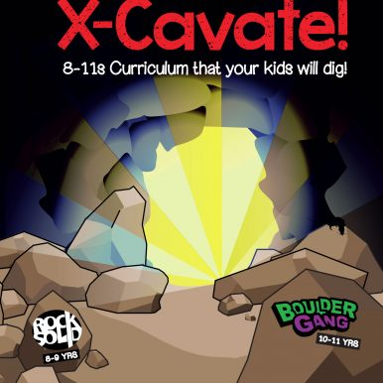
x-Cavate is a curriculum available from New Wine. There are pre-school, 5-7 and 8-11 resources with 10 sessions in each book. There is interactive Bible teaching, online resources, quiet and lively activities and tips on including everyone.

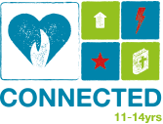
Connected will help your children and young people develop hearts that are connected to God, each other and the community around them. They will explore who God is, their identity in Him and develop a relationship with a living God who loves and treasures them. Connected covers what it means to be powerful and free, how to develop two way conversation with God, healing, compassion, generosity, risk and much more. There is a year’s worth of plans for both under 5-10’s and 11-14’s
https://connectedhearts.co.uk/

For Churches that follow the Lectionary

Ministry-to-children.com – Lectionary based website and searchable. Ministry-To-Children.com provide age-appropriate Bible study material and Sunday School curriculum.
Seems to have some good ideas – interactive options and downloadable content.
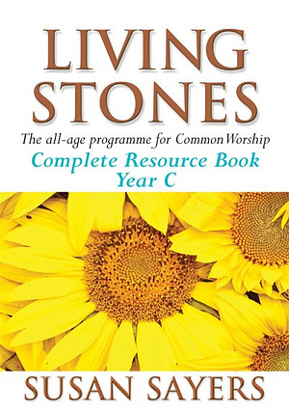
Living Stones: Susan Sayers has created a complete all-age, all-stage package to help parishes get the best out of the Common Worship Lectionary. It has ideas, outlines, intercessions, mini-dramas and much more. It is an entirely practical book which explores the texts of the new Lectionary, teases out the meaning and opportunities inherent in them and then offers plenty of ideas, suggestions and encouragement.
Each Sunday includes a Thought for the Day, Notes on the Reading, Discussion Starters, background material for an All-age Talk, All-stage plus All-age Ideas, a complete set of Intercessions and suggestions for music. There are fully worked-out programmes for pre-school children, children and young people.

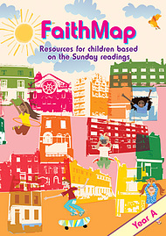
Faith Map offers materials based on the scriptures for a full year. Each week features stories, discussion ideas, prayers and an activity sheet inspired by the days readings.
Its written with enough detail to enable the leader/parent to share their faith with a group of children, without hours of preparation. There are separate stories for young ones and juniors, so that you can tailor sessions to the needs of your group. There is also family take-home sheet for each week, encouraging children to take the message of the Gospel back into their homes.
Each session starts with an introduction to the theme; the Bible readings; response to scripture using a story (separate suggestions for different age groups); activity (again appropriate suggestions for different groups and tips for learning difficulties); the sessions ends with a prayer and share time and a singing a few songs.
The material can be used in both Catholic and Anglican traditions.

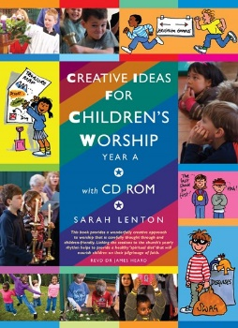
Creative Ideas for Children’s Worship Years A,B and C
The worship outlines include simple children's liturgies and a complete lesson or story plan that harmonizes with what the adults are doing in church on the same day. Through fun ideas, children encounter a real aspect of the Christian faith focused on a theme to be found in the Gospel of the day. Each outline includes a variety of options which make them workable with small and large groups of children or single groups of mixed ages. Illustrated throughout, the text and artwork appears on the accompanying CD Rom in full colour for downloading and printing or copying.

Story Path – is a website where they have connected children’s books and use them to illustrate the lectionary topics.
http://storypath.upsem.edu/lectionary-links/lectionary-links-revised-common-lectionary/

ROOTS
Each week, ROOTS material covers adult, all age and children & young people with resources to explore the same passage from the Revised Common Lectionary. Where Common Worship differs there are other materials online.
Children & Young People resources covers toddlers to teens with resources for Sunday Groups, Youth Groups, midweek clubs, assemblies, toddler groups and resources for Nurturing faith at home for families and individuals.

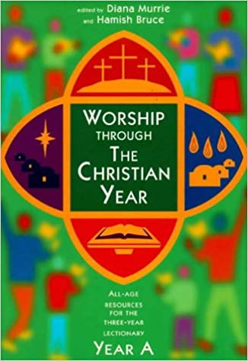
Worship through the Christian Year
Available from amazon

Sermons For Kids www.sermons4kids.com
An online US resource (there is a charge for using it).
It has a story - rather light and simplistic especially if working with older children. It has resources for each – colouring, wordsearch etc.

Seasons of the Spirit – A US resource which has materials for all ages – inc adult. Costly but reasonable.

Energise.uk.net from Urban Saints – not specifically Lectionary based but is searchable so can be adapted. £20/month
One Energize subscription enables you to access high-quality, age-appropriate, Bible-based resources for every stage of a young person's development. Energize will equip you to understand, engage with and respond to their needs, from ages 3 to 15+.

Scripture Union
Their Light Material is available under the resources section of their website to download for free. There is a search bar to help locate what you need.


Journey Together is their new syllabus materials following the Common Worship Lectionary Calendar. Each week comes with discussion starters, games, crafts, spiritual training activities and object lessons just like their other materials. There is also a one page Faith at Home sheet in a similar style to the previous Together at Home packs. They have an an 8 week sample pack for just £5 and are offering the whole of the first year for just £52.
https://www.foundationstones.co.uk/online-shop/Journey-Together-c116971010

Raise Up Faith is a curriculum platform. Created to resource youth and children’s ministry with multimedia content and curriculum. Designed to draw young minds, and inspire young hearts.
With lesson plans, and content from brands like New Wine, Little Worship Company, Treasure Champs, LZ7, and Spring Harvest’s Big Start. There is a cost to the platform but it is constantly being added to.

The following are useful websites for additional resources
Crafting the word of God.com
Danielle’s Place.com
DLTK-kids.com
Flamecreativeblogspot
Free Bible Images
Many of the Bible stories are broken down into a series of pictures which are free to use.
www.freebibleimages.org
Creative Bible Study Is a US website with free access to series of materials for pre-schoolers, children and youth. www.creativebiblestudy.com

