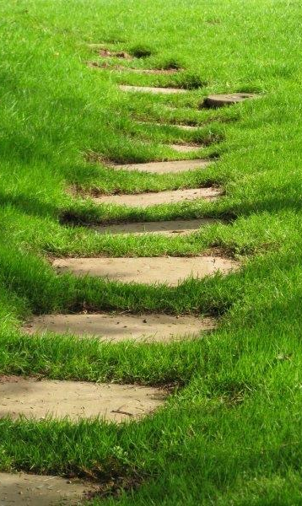

Where?
65 Maidstone Road, Chatham
ME4 6DP

Christ Church Chislehurst 40 Lubbock Road, Chislehurst BR7 5JJ
One line (zoom)
For more info about the next Closer course contact: Rev Canon Susanne Carlsson (Adviser for Spirituality in Rochester Diocese)
susannecarlssons@hotmail.co.uk
07795167603
Suggested Donation? 10-15 per session

Closer…
Exploring Christian Spirituality

Closer…
Who is this who calls me close?

Love calls love: meet me…

Closer…
Exploring Christian Spirituality

Saturdays 10.30
Session 1 What is Prayer?
Session 2 Images of God and Self
Session 3 Different Ways of Praying
Session 4 Different Ways of Praying
Session 5 Discernment and Decision Making
Session 6 Different Spiritualities
Session 7 Deepening and Review

You need to attend all sessions and you will be encouraged to use what you learnt in between sessions.

Closer…

is a one year experiential course in Christian Spirituality.
The course will offer both exploration and experience of the depth of Christian Spirituality.

The participants will:

- Explore and develop their own relationship with God.
- Try new ways of praying.
- Learn about different Christian Spiritualities.
- Explore discernment and decision making.

