

Ordination
of Deacons

Saturday 30th September 2023
at 3.00pm



Growing in Christ since AD604

Welcome to Rochester Cathedral – a place of Christian worship since AD604.

Please be aware that this service is being live streamed. If you do not wish to be filmed or have any concerns, please make yourself known to one of the stewards.

Invitations as to posture are indicative – please stand/sit as you are able.


Please do not take photographs,
sound or video recordings during the service.
As part of our safeguarding, no photography of children
is permitted in the Cathedral.


An induction loop system is installed in the Cathedral.
Hearing aid users should adjust their aid to T.


Large print orders of service are available.

Copyright words and music for the musical items are reproduced under
Christian Copyright Licence number 31535,
CCLI Music Reproduction Licence number 903106 and Calamus Licence number 1019.
Material from Common Worship which is included in this service is copyright: © The Archbishops Council, 2000
Quotations from The New Revised Standard Version of the Bible,
Anglicized Edition, are copyright © 1989, 1995 by the Division of Christian Education of the National Council of Churches
in the USA, and are used by permission. All rights reserved.

The Ordination of Deacons

The ministry of the Church is the ministry of Christ, its chief shepherd and high priest. The ordained ministry is Christ’s gift to his Church, and in their life and ministry, bishops, priests and deacons are called to speak in Christ’s name and build up the Church of which he is the head. In this way the whole body of the Church is ordered in faithful response to the Lord’s summons to share his work.

The ministry of deacons is focussed in being heralds of the kingdom and in bringing before the servant Church the needs of the world.

from ‘Introduction by the House of Bishops’ to
Common Worship: Ordination Services (2007)

Before this service, the Ordinands have taken the Oath of Allegiance to His Majesty the King and the Oath of Canonical Obedience to the Bishop, and made the following Declaration of Assent:

Preface

The Church of England is part of the One, Holy, Catholic, and Apostolic Church, worshipping the one true God, Father, Son, and Holy Spirit. It professes the faith uniquely revealed in the Holy Scriptures and set forth in the catholic creeds, which faith the Church is called upon to proclaim afresh in each generation. Led by the Holy Spirit, it has borne witness to Christian truth in its historic formularies, the Thirty-nine Articles of Religion, The Book of Common Prayer and the Ordering of Bishops, Priests and Deacons. In the declaration you are about to make, will you affirm your loyalty to this inheritance of faith as your inspiration and guidance under God in bringing the grace and truth of Christ to this generation and making Him known to those in your care?

Declaration of Assent

I, N, do so affirm, and accordingly declare my belief in the faith which is revealed in the Holy Scriptures and set forth in the catholic creeds and to which the historic formularies of the Church of England bear witness; and in public prayer and administration of the sacraments, I will use only the forms of service which are authorized or allowed by Canon.
The Ordinands

James Butler
to serve in the benefice of Crayford

Robert Byrne
to serve in the benefice of Christ Church, Tunbridge Wells

Anna Drew
to serve in the benefice of Holy Trinity, Gillingham

Hannah Glover
to serve in the benefice of Weald

Jessica Heeb
to serve in the benefice of Snodland with Lower Birling

Mark Morgan
to serve in the benefice of Chalk

Raymond Shergill
to serve in the benefice of Holy Trinity with St John, Penge

Andrew Smith
to serve in the parish of Holy Trinity, Lamorbey

Roberta Woodward
to serve in the benefice of Barming with Teston

Pray for all those to be ordained deacon today, as they begin their new ministry.

ORDER OF SERVICE

The Dean, the Very Reverend Dr Philip Hesketh, welcomes the congregation and gives out any notices.

Remain seated as supporting clergy and reader/LLMs process to their seats.

The Gathering and Presentation

All stand as the procession enters the Nave via the Great West Door and a fanfare is sounded

Hymn

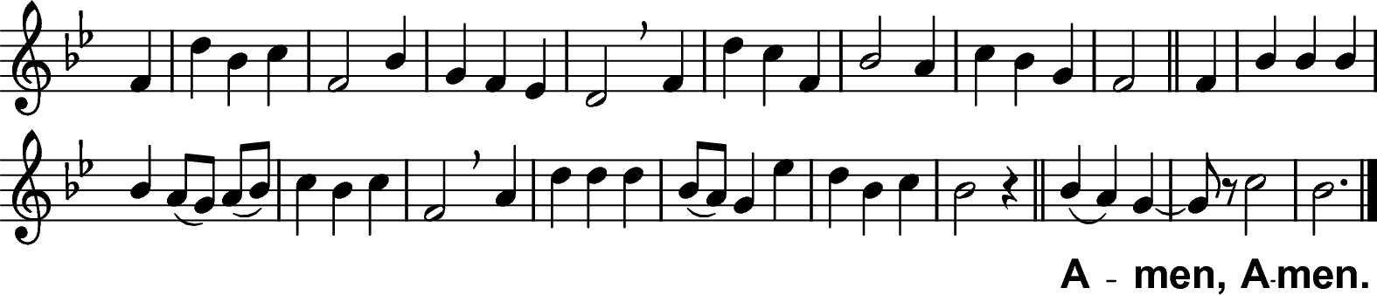
³ O praise ye the Lord!
All things that give sound;
Each jubilant chord,
Re-echo around;
Loud organs, his glory
Forth tell in deep tone,
And sweet harp, the story
Of what he hath done.

⁴ O praise ye the Lord!
Thanksgiving and song
To him be outpoured
All ages along:
For love in creation,
For heaven restored,
For grace of salvation,
O praise ye the Lord!
(Amen Amen).
¹ O praise ye the Lord!
Praise him in the height;
Rejoice in his word,
Ye angels of light;
Ye heavens adore him
By whom ye were made,
And worship before him,
In brightness arrayed.

² O praise ye the Lord!
Praise him upon earth,
In tuneful accord,
Ye sons of new birth;
Praise him who hath brought you
His grace from above,
Praise him who hath taught you
To sing of his love.

Laudate Dominum (427) ~ C Hubert H Parry (1848-1918) H W Baker (1821-1877)

Remain standing

Bishop Blessed be God, Father, Son and Holy Spirit.
All Blessed be his kingdom, now and for ever. Amen.

There is one body and one spirit.
All There is one hope to which we were called;

one Lord, one faith, one baptism,
All one God and Father of all.

Peace be with you
All and also with you.

Sit

The Ordinands remain standing

The Bishop introduces the service

God calls his people to follow Christ, and forms us into a royal priesthood, a holy nation, to declare the wonderful deeds of him who has called us out of darkness into his marvellous light.

The Church is the Body of Christ, the people of God and the dwelling-place of the Holy Spirit. In baptism the whole Church is summoned to witness to God’s love and to work for the coming of his kingdom.

To serve this royal priesthood, God has given a variety of ministries. Deacons are ordained so that the people of God may be better equipped to make Christ known. Theirs is a life of visible self-giving. Christ is the pattern of their calling and their commission; as he washed the feet of his disciples, so they must wash the feet of others.

Prayers of Penitence

The Deacon of the Liturgy, The Revd Stephen Osei-Mensah, says

Deacon As we gather before God,
and trusting in his grace alone,
let us join with these ordinands in confessing our sins.

After a silence

All Almighty God, our heavenly Father,
we have sinned against you
and against our neighbour
in thought and word and deed,
through negligence, through weakness,
through our own deliberate fault.
We are truly sorry
and repent of all our sins.
For the sake of your Son Jesus Christ,
who died for us,
forgive us all that is past
and grant that we may serve you in newness of life
to the glory of your name.
Amen.

Bishop Almighty God,
who forgives all who truly repent,
have mercy upon you,
pardon and deliver you from all your sins,
confirm and strengthen you in all goodness,
and keep you in life eternal;
through Jesus Christ our Lord.
All Amen.

The Presentation

Each Archdeacon presents the Ordinands from their Archdeaconry.

Archdeacon Reverend Father in God,
I present <N>
from the Archdeaconry of Bromley and Bexley / Rochester / Tonbridge
to be ordained to the office of deacon in the Church of God …

When the Ordinands have been presented, the Bishop asks the Diocesan Director of Ordinands and Vocations

Bishop Have those whose duty it is to know these ordinands and examine them found them to be of godly life and sound learning?

Director of
Ordinands They have.

Bishop Do they believe them to be duly called to serve God in this ministry?

Director of
Ordinands They do.

The Bishop addresses the Ordinands

Bishop Do you believe that God is calling you to this ministry?

Ordinands I do so believe.

Bishop I invite the Archdeacon to confirm that the Ordinands have taken the necessary oaths and made the Declaration of Assent.

Archdeacon They have duly taken the oath of allegiance to the Sovereign and the oath of canonical obedience to the bishop. They have affirmed and declared their belief in 'the faith which is revealed in the Holy Scriptures and set forth in the catholic creeds and to which the historic formularies of the Church of England bear witness'.

The Collect

Bishop Let us pray for those to be ordained today,
and for the ministry of the whole people of God.

After a short period of silent prayer:

God our Father, Lord of all the world,
through your Son you have called us into the fellowship
of your universal Church:
hear our prayer for your faithful people
that in their vocation and ministry
each may be an instrument of your love,
and give to your servants now to be ordained
the needful gifts of grace;
through our Lord and Saviour Jesus Christ,
who is alive and reigns with you,
in the unity of the Holy Spirit,
one God, now and for ever.
All Amen.

Sit

The Liturgy of the Word

First Reading: Jeremiah 1.1-10
read by Mariam Shergill

A reading from the prophecy of Jeremiah.
Now the word of the Lord came to Jeremiah saying,
‘Before I formed you in the womb I knew you,
and before you were born I consecrated you;
I appointed you a prophet to the nations.’
Then I said, ‘Ah, Lord God! Truly I do not know how to speak, for I am only a boy.’ But the Lord said to me,
‘Do not say, “I am only a boy”;
for you shall go to all to whom I send you,
and you shall speak whatever I command you.
Do not be afraid of them,
for I am with you to deliver you,
says the Lord.’
Then the Lord put out his hand and touched my mouth; and the Lord said to me,
‘Now I have put my words in your mouth.
See, today I appoint you over nations and over kingdoms,
to pluck up and to pull down,
to destroy and to overthrow,
to build and to plant.’

Reader For the word of the Lord.
All Thanks be to God.

Stand

Hymn

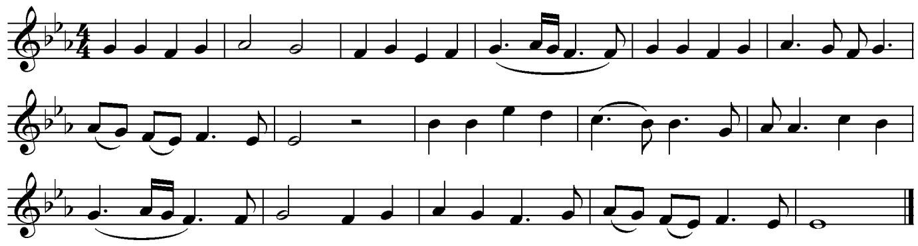
² Jesus my Redeemer,
Name above all names,
Precious Lamb of God, Messiah,
O for sinners slain:
Thank you, O my Father,
For giving us your Son,
And leaving your Spirit
Till the work on earth is done.

¹ There is a Redeemer,
Jesus, God's own Son,
Precious Lamb of God, Messiah,
Holy One.
Thank you, O my Father,
For giving us your Son,
And leaving your Spirit
Till the work on earth is done.

³ When I stand in glory
I will see his face,
And there I'll serve my King for ever
In that holy place.
Thank you, O my Father,
For giving us your Son,
And leaving your Spirit
Till the work on earth is done.

Keith Green (1953-1982) and Melody Green (b.1946)
Copyright © 1982 Birdwing Music (AM 805)

Sit

Second Reading: 2 Corinthians 6.1-10
read by Claire Boxall, Called Together Manager.

A reading from the second letter of Paul to the Corinthians.

As we work together with him, we urge you also not to accept the grace of God in vain. For he says,

‘At an acceptable time I have listened to you,
and on a day of salvation I have helped you.’
See, now is the acceptable time; see, now is the day of salvation! We are putting no obstacle in anyone’s way, so that no fault may be found with our ministry, but as servants of God we have commended ourselves in every way: through great endurance, in afflictions, hardships, calamities, beatings, imprisonments, riots, labours, sleepless nights, hunger; by purity, knowledge, patience, kindness, holiness of spirit, genuine love, truthful speech, and the power of God; with the weapons of righteousness for the right hand and for the left; in honour and dishonour, in ill repute and good repute. We are treated as impostors, and yet are true; as unknown, and yet are well known; as dying, and see—we are alive; as punished, and yet not killed; as sorrowful, yet always rejoicing; as poor, yet making many rich; as having nothing, and yet possessing everything.
Reader For the word of the Lord.
All Thanks be to God.

Stand

Gospel Acclamation
Turn to face the gospel book as it passes through the congregation

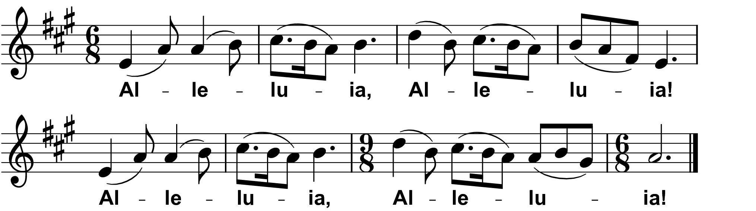
Fintan O'Carroll / Christopher Walker © 1985 OCP Publications

Choir Alleluia, Alleluia! Alleluia, Alleluia!
All Alleluia, Alleluia! Alleluia, Alleluia!

Choir I chose you and appointed you, says the Lord,
that you should go and bear fruit that shall last.
All Alleluia, Alleluia! Alleluia, Alleluia!
Gospel Reading: Luke 5.1-11

Deacon The Lord be with you
All and also with you

Deacon Hear the Gospel of our Lord Jesus Christ according to Luke.
All Glory to you, O Lord.

Once while Jesus was standing beside the lake of Gennesaret, and the crowd was pressing in on him to hear the word of God, he saw two boats there at the shore of the lake; the fishermen had gone out of them and were washing their nets. He got into one of the boats, the one belonging to Simon, and asked him to put out a little way from the shore. Then he sat down and taught the crowds from the boat. When he had finished speaking, he said to Simon, ‘Put out into the deep water and let down your nets for a catch.’ Simon answered, ‘Master, we have worked all night long but have caught nothing. Yet if you say so, I will let down the nets.’ When they had done this, they caught so many fish that their nets were beginning to break. So they signalled to their partners in the other boat to come and help them. And they came and filled both boats, so that they began to sink. But when Simon Peter saw it, he fell down at Jesus’ knees, saying, ‘Go away from me, Lord, for I am a sinful man!’ For he and all who were with him were amazed at the catch of fish that they had taken; and so also were James and John, sons of Zebedee, who were partners with Simon. Then Jesus said to Simon, ‘Do not be afraid; from now on you will be catching people.’ When they had brought their boats to shore, they left everything and followed him.

Deacon This is the Gospel of the Lord.
All Praise to you, O Christ.

Once the Sermon has been introduced, please sit

Sermon
by The Venerable Sharon Copestake, Archdeacon of Tonbridge &
Ordination Retreat Conductor.

Stand

The Creed

Bishop Let us declare our faith in God,
Father, Son and Holy Spirit.

All We believe in one God,
the Father, the Almighty,
maker of heaven and earth,
of all that is,
seen and unseen.
We believe in one Lord, Jesus Christ,
the only Son of God,
eternally begotten of the Father,
God from God, Light from Light,
true God from true God,
begotten, not made,
of one Being with the Father;
through him all things were made.
For us and for our salvation he came down from heaven,
was incarnate from the Holy Spirit and the Virgin Mary
and was made man.
For our sake he was crucified under Pontius Pilate;
he suffered death and was buried.
On the third day he rose again
in accordance with the Scriptures;
he ascended into heaven
and is seated at the right hand of the Father.
He will come again in glory to judge the living and the dead,
and his kingdom will have no end.
We believe in the Holy Spirit,
the Lord, the giver of life,
who proceeds from the Father and the Son,
who with the Father and the Son is worshipped and glorified,
who has spoken through the prophets.
We believe in one holy catholic and apostolic Church.
We acknowledge one baptism for the forgiveness of sins.
We look for the resurrection of the dead,
and the life of the world to come.
Amen.

The congregation sits
The Liturgy of Ordination

The Declarations

The Ordinands stand before the Bishop

The Bishop addresses the congregation

Deacons are called to work with the Bishop and the priests with whom they serve as heralds of Christ’s kingdom. They are to proclaim the gospel in word and deed, as agents of God’s purposes of love. They are to serve the community in which they are set, bringing to the Church the needs and hopes of all the people. They are to work with their fellow members in searching out the poor and weak, the sick and lonely and those who are oppressed and powerless, reaching into the forgotten corners of the world, that the love of God may be made visible.

Deacons share in the pastoral ministry of the Church and in leading God’s people in worship. They preach the word and bring the needs of the world before the Church in intercession. They accompany those searching for faith and bring them to baptism. They assist in administering the sacraments; they distribute communion and minister to the sick and housebound.

Deacons are to seek nourishment from the Scriptures; they are to study them with God’s people, that the whole Church may be equipped to live out the gospel in the world. They are to be faithful in prayer, expectant and watchful for the signs of God’s presence, as he reveals his kingdom among us.

The Bishop addresses the Ordinands directly

We trust that you are fully determined, by the grace of God, to give yourself wholly to his service, that you may draw his people into that new life which God has prepared for those who love him.

The Bishop of Tonbridge address the Ordinands

Bishop of And now, in order that we may know your mind and purpose, you must
Tonbridge make the declarations we put to you.

Do you accept the Holy Scriptures as revealing all things necessary for eternal salvation through faith in Jesus Christ?
Ordinands I do so accept them.

Will you be diligent in prayer, in reading Holy Scripture, and in all studies that will deepen your faith and fit you to bear witness to the truth of the gospel?
By the help of God, I will.

Do you believe the doctrine of the Christian faith as the Church of England has received it, and in your ministry will you expound and teach it?
I believe it and will do so.

Will you strive to make the love of Christ known through word and example, and have a particular care for those in need?
By the help of God, I will.

Will you be a faithful servant in the household of God, after the example of Christ, who came not to be served but to serve?
By the help of God, I will.

Will you endeavour to fashion your own life and that of your household according to the way of Christ, that you may be a pattern and example to Christ’s people?
By the help of God, I will.

Will you work with your fellow servants in the gospel for the sake of the kingdom of God?
By the help of God, I will.

Will you accept the discipline of this Church and give due respect to those in authority?
By the help of God, I will.

Will you then, in the strength of the Holy Spirit, continually stir up the gift of God that is in you, to grow in holiness and grace?
By the help of God, I will.

The congregation stands and the Ordinands turn and face them

The Bishop address the congregation

Bishop Brothers and sisters, you have heard how great is the charge that these ordinands are ready to undertake, and you have heard their declarations. Is it now your will that they should be ordained?
All It is.

Will you continually pray for them?
All We will.

Will you uphold and encourage them in their ministry?
All We will.

The Ordinands turn back to face the Bishop

Bishop In the name of our Lord, we bid you remember the greatness of the trust in which you are now to share: the ministry of Christ himself, who for our sake took the form of a servant. Remember always with thanksgiving that the people among whom you will minister are made in God’s image and likeness. In serving them you are serving Christ himself, before whom you will be called to account.

You cannot bear the weight of this calling in your own strength, but only by the grace and power of God. Pray therefore that your heart may daily be enlarged and your understanding of the Scriptures enlightened.

Pray earnestly for the gift of the Holy Spirit.

The congregation sit and silence is kept

Litany
led by Assistant Diocesan Directors of Ordinands

In the power of the Spirit and in union with Christ,
let us pray to the Father.
All Lord, have mercy.

For the peace of the whole world,
for the welfare of the Holy Church of God, and for the unity of all,
let us pray to the Lord.
All Lord, have mercy.

For all the members of the Church in their vocation and ministry,
that they may serve him in truth and love,
let us pray to the Lord.
All Lord, have mercy.

For Jonathan our bishop,
Simon, Bishop of Tonbridge,
and for all bishops, presbyters and deacons,
that they may hunger for truth and thirst after righteousness,
let us pray to the Lord.
All Lord, have mercy.

For those called to be deacons in the Church,
let us pray to the Lord.
All Lord, have mercy.

For the mission of the Church, that in faithful witness we may proclaim the gospel of reconciliation to the ends of the earth,
let us pray to the Lord.
All Lord, have mercy.

For the unity of the Church, that we may be one in Christ,
according to his will,
let us pray to the Lord.
All Lord, have mercy.

For those who do not yet believe, that they may receive the light of the gospel, and for those whose faith has grown cold,
let us pray to the Lord.
All Lord, have mercy.

For the sick and suffering, for the aged and infirm, for the lonely and neglected, and for all who remember and care for them,
let us pray to the Lord.
All Lord, have mercy.

For the poor and the hungry, for the homeless and the oppressed,
for all prisoners and captives, and for our brothers and sisters
who are persecuted for their faith,
let us pray to the Lord.
All Lord, have mercy.

For Charles our King, for the leaders of the nations,
and for all in authority,
let us pray to the Lord.
All Lord, have mercy.

For ourselves, for grace to repent and amend our lives,
that we may be pardoned and absolved from all our sins,
let us pray to the Lord.
All Lord, have mercy.

Remembering all who have gone before us in faith,
and in communion with all the saints, we commit ourselves,
one another, and our whole life to Christ our God;
All To you, O Lord.

The Ordination Prayer

The Bishop stands to pray

Bishop We praise and glorify you, almighty Father,
because in your infinite love you have formed throughout the world
a holy people for your own possession,
a royal priesthood, a universal Church.

We praise and glorify you
because you have given us your only Son Jesus Christ,
the image of your eternal and invisible glory,
the firstborn of all creation and head of the Church.

We praise and glorify you
because in every age you send your Spirit
to fill those whom you have chosen,
to equip your holy people for the work of ministry,
for the building up of the body of Christ.

And now we give you thanks
that you have called these your servants,
whom we ordain in your name,
to share as deacons in the ministry of the gospel of Christ,
who came not to be served but to serve,
and to give his life as a ransom for many.

Therefore, Father, through Christ our Lord we pray:

(Supporters are invited to stand when their Ordinand stands before the Bishop)

Here the Bishop lays his hands on the head of each Ordinand, saying

Send down the Holy Spirit on your servant …
for the office and work of a deacon in your Church.

When the Bishop has laid hands on all of the Ordinands, the prayer continues

Through your Spirit, heavenly Father,
give these your servants grace and power to fulfil their ministry.
Make them faithful to serve
and constant in advancing your gospel in the world.
May they follow the example of Jesus Christ your Son,
who washed the feet of his disciples,
and set the needs of others before his own.

May their life be disciplined and holy,
their words declare your love
and their actions reveal your glory,
that your people may walk with them in the way of truth
and be made ready for the coming of our Lord Jesus Christ;
to whom, with you and your Holy Spirit,
belong glory and honour, worship and praise, now and for ever.
All Amen.

The Vesting

The newly ordained deacons are given a stole and they are assisted to vest the stole deacon-wise

During the vesting, the choir sings
³ Worldly joys, like shadows fade
When the heavenly light appears;
But the covenants thou hast made,
Endless, know nor days, nor years.

⁴ In thy word, Lord, is my trust,
To thy mercies fast I fly;
Though I am but clay and dust,
Yet thy grace can lift me high.

¹ View me, Lord, a work of thine:
Shall I then lie drowned in night?
Might thy grace in me but shine,
I should seem made all of light.

² Cleanse me, Lord, that I may kneel
At thine altar, pure and white;
They that once thy mercies feel,
Gaze no more on earth’s delight.

Richard Lloyd (b.1933) Thomas Campion (1567-1620)

The Welcome

All stand

A deacon says to the newly ordained deacons

We preach not ourselves but Christ Jesus as Lord
and ourselves as your servants for Jesus’ sake.

All We welcome you as fellow servants in the gospel:
may Christ dwell in your hearts through faith,
that you may be rooted and grounded in love.

The newly ordained deacons are welcomed with applause

The Liturgy of the Eucharist

Stand

The Peace

Bishop God has entrusted to us the message of reconciliation.
First be reconciled to one another.

The peace of the Lord be always with you
All and also with you.

Deacon Let us offer one another a sign of peace.

Preparation of the Table

Taking of the Bread and Wine

Offertory Hymn
during which the collection is taken.

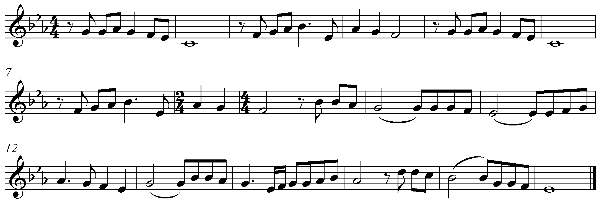

From heav’n you came helpless babe
Enter’d our world your glory veil’d
Not to be served but to serve
And give Your life that we might live.

Refrain:
This is our God, the Servant King –
He calls us now to follow Him
To bring our lives as a daily offering
of worship to the Servant King

There in the garden of tears
My heavy load He chose to bear.
His heart with sorrow was torn
Yet “Not my will, but yours”, He said.
Refrain

Come see His hands and His feet -
The scars that speak of sacrifice
Hands that flung stars into space
To cruel nails surrendered.
Refrain

So let us learn how to serve
And in our lives enthrone Him.
Each other’s needs to prefer
For it is Christ we’re serving.
Refrain

The Servant King (AM489) (420) Graham Kendrick (b. 1950)

The Bishop takes the bread and wine

Bishop Heavenly Father,
as we set before you these gifts of bread and wine,
bless also the gift of our hearts and minds
as we offer our lives in your service;
for Jesus Christ’s sake.
All Amen.

Eucharistic Prayer E

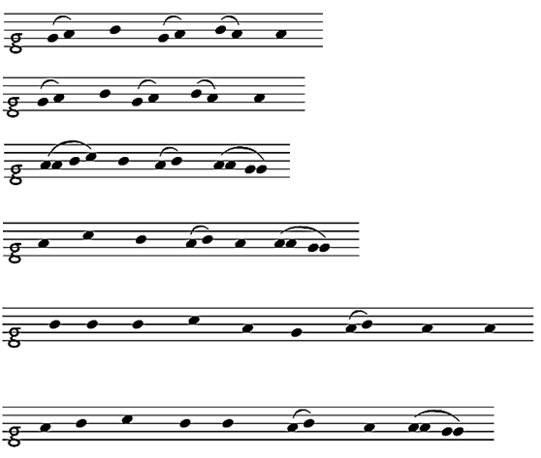
President The Lord be with you.

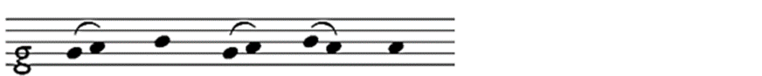
All and al – so with you.

President Lift up your hearts.

All We lift them to the Lord.

President Let us give thanks to the Lord our God.

All It is right to give thanks and praise.

Bishop It is indeed right and good,
our duty and our salvation,
always and everywhere to give you thanks and praise
through your servant, Jesus Christ our Lord.

At his baptism he was revealed as your beloved Son.
Coming among us as one who serves,
he taught us that the greatest in your kingdom
are those who make themselves least and the servants of all.

Although he was their teacher and their Lord,
he washed the feet of his disciples
and commanded us to do the same,
that we might reveal the power of your love,
made perfect in our human weakness.

Therefore with angels and archangels,
and with all the company of heaven,
we proclaim your great and glorious name,
for ever praising you and singing:
Choir Holy, holy, holy, Lord God of hosts,
Heaven and earth are full of thy glory.
Glory be to thee, O Lord most high.
Blessed is he that cometh in the name of the Lord.
Hosanna in the highest.

Charles Villiers Stanford (1852-1924) Communion Service in B-flat

Bishop We praise and bless you, loving Father,
through Jesus Christ, our Lord;
and as we obey his command,
send your Holy Spirit,
that broken bread and wine outpoured
may be for us the body and blood of your dear Son.

On the night before he died he had supper with his friends
and, taking bread, he praised you.
He broke the bread, gave it to them and said:
Take, eat; this is my body which is given for you;
do this in remembrance of me.

When supper was ended he took the cup of wine.
Again he praised you, gave it to them and said:
Drink this, all of you;
this is my blood of the new covenant,
which is shed for you and for many for the forgiveness of sins.
Do this, as often as you drink it, in remembrance of me.

So, Father, we remember all that Jesus did,
in him we plead with confidence his sacrifice
made once for all upon the cross.
Bringing before you the bread of life and cup of salvation,
we proclaim his death and resurrection
until he comes in glory.
Deacon Great is the mystery of faith.
All Christ has died:
Christ is risen:
Christ will come again.

Bishop Lord of all life,
help us to work together for that day
when your kingdom comes
and justice and mercy will be seen in all the earth.

Look with favour on your people,
gather us in your loving arms
and bring us with the Blessed Virgin Mary
and all the saints
to feast at your table in heaven.

Through Christ, and with Christ, and in Christ,
in the unity of the Holy Spirit,
all honour and glory are yours, O loving Father,
for ever and ever.
All Amen.

Kneel or sit

The Lord’s Prayer

Bishop As our Saviour taught us, so we pray
All Our Father in heaven,
hallowed be your name,
your kingdom come,
your will be done,
on earth as in heaven.
Give us today our daily bread.
Forgive us our sins,
as we forgive those who sin against us.
Lead us not into temptation,
but deliver us from evil.
For the kingdom, the power
and the glory are yours
now and for ever.
Amen.

Breaking of the Bread

Bishop We break this bread
to share in the body of Christ.
All Though we are many, we are one body,
because we all share in one bread.

Giving of Communion

Bishop Jesus is the Lamb of God
who takes away the sin of the world.
Blessed are those who are called to his supper.
All Lord, I am not worthy to receive you,
but only say the word, and I shall be healed.

Choir O Lamb of God.
that takest away the sins of the world,
have mercy upon us / grant us thy peace.

Charles Villiers Stanford (1852-1924) Communion Service in B-flat

All who are regular communicants in their own churches are welcome to receive communion here. Gluten-free hosts are available: please ask the stewards and come to the stations at the front of the Nave. If you wish to come for a blessing instead of receiving communion, please carry this service paper with you as a sign to the minister. We keep a prayerful silence to allow others to prepare to receive communion or pray afterwards. Please follow the directions of the stewards.

Anthem

Come down, O love divine, seek thou this soul of mine,
And visit it with thine own ardor glowing.
O Comforter, draw near, within my heart appear,
And kindle it, Thy holy flame bestowing.

O let it freely burn, til earthly passions turn
To dust and ashes in its heat consuming;
And let Thy glorious light shine ever on my sight,
And clothe me round, the while my path illuming.

Let holy charity mine outward vesture be,
And lowliness become mine inner clothing;
True lowliness of heart, which takes the humbler part,
And o’er its own shortcomings weeps with loathing.

And so the yearning strong, with which the soul will long,
Shall far outpass the power of human telling;
For none can guess its grace, till he become the place
Wherein the Holy Spirit makes a dwelling.

William Harris (1883-1973) Bianco da Siena (d 1434)

Hymn

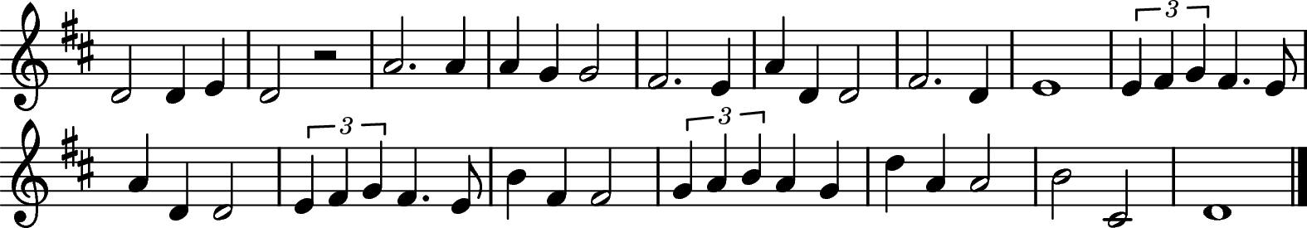

Lord Jesus Christ
You have come to us,
You are one with us,
Mary's Son;
Cleansing our souls from all their sin,
Pouring your love and goodness in;
Jesus, our love for you we sing,
Living Lord.

Lord Jesus Christ,
Now and every day
Teach us how to pray,
Son of God.
You have commanded us to do
This in remembrance, Lord, of you;
Into our lives your power breaks through,
Living Lord.

Lord Jesus Christ,
You have come to us,
Born as one of us,
Mary's Son;
Led out to die on Calvary,
Risen from death to set us free,
Living Lord Jesus, help us see
You are Lord.

Lord Jesus Christ,
I would come to you,
Live my life for you,
Son of God.
All your commands I know are true,
Your many gifts will make me new,
Into my life your power breaks through,
Living Lord.

Living Lord Patrick Robert Norman Appleford (1925-2018)

Prayer after Communion

Bishop Let us pray.

Stand

Bishop Holy and blessed God,
you have fed us with the body and blood of your Son
and filled us with your Holy Spirit:
may we honour you,
not only with our lips
but in lives dedicated to the service
of Jesus Christ our Lord.
All Amen.

All We thank you, gracious Father,
for welcoming your children to feast in your kingdom;
by your love unite us
and with your Spirit send us,
in the name of Jesus Christ our Lord.
Amen.

Hymn

during which the Bishop gives the Bible to each of the newly ordained deacons

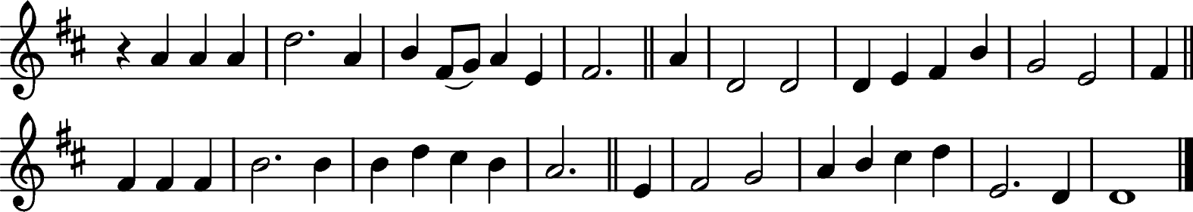

Hope of our calling: hope through courage won
By those who dared to share all Christ had done.
Saints of today, Christ's banner now unfurled,
Will bring his gospel to a waiting world.

Hope of our calling: hope with strength empowered,
Inspired by all that we have seen and heard;
This call is ours, for we are chosen too,
To live for God in all we say and do.

Hope of our calling: hope with grace outpoured,
From death's despair the gift of life restored;
Our call to serve, to wash each other's feet,
To bring Christ's healing touch to all we meet.

Hope of our calling: hope by faith made bold
To sow God's righteousness throughout the world;
Bring peace from conflict, fruitfulness from weeds,
The kingdom's harvest from the kingdom's seeds.

Hope of our calling: Spirit-filled, unbound,
Old joys remembered and new purpose found,
Our call refreshed by sacrament and word,
We go in peace to love and serve the Lord.

Woodlands (395) ~ Walter Greatorex (1877-1949) Ally Barrett (b. 1975)

The Sending Out

The Giving of the Bible

Bishop Receive this book,
as a sign of the authority given you this day
to speak God’s word to his people.
Build them up in his truth
and serve them in his name.

Blessing and Dismissal

Bishop Our help is in the name of the Lord,
All who has made heaven and earth.

Blessed be the name of the Lord,
All now and forever. Amen.

God who has called you is faithful.

May the Father, whose glory fills the heavens,
cleanse you by his holiness
and send you to proclaim his word.
All Amen.

May Christ, who has ascended to the heights,
pour upon you the riches of his grace.
All Amen.

May the Holy Spirit, the comforter,
equip you and strengthen you in your ministry.
All Amen.

And the blessing of God almighty,
the Father, the Son and the Holy Spirit,
be among you and remain with you always.
All Amen.

Deacon Go in the peace of Christ.
All Thanks be to God.

The Bishop leads the newly ordained deacons to the Great West Door and the other ministers exit in procession

Recession

Order of recession:
via Central Aisle to Great West Door
Verger
+J, leading…
New Deacons
+Simon
Bishop’s Chaplain

Short exit route via South Nave Aisle and Kent Steps direct to
Quire Crossing i.e. avoiding log jam at Kent Steps
i+i
Choir
Visiting Bishops
DDO IME2
Archdeacons
Deacon
Chapter
Preacher with PJH

Short exit route via South Nave Aisle direct to Crypt
Verger
Readers
Supporting Clergy

PJH to lead Quire crossing vestry prayer.
CD to lead crypt vestry prayer.

Organ Voluntary

