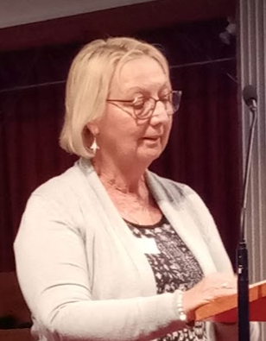
Good News

Jennie Spalding, LLM and Anna Chaplain, spoke about starting a monthly Messy Vintage, offering a monthly Carers Drop in coffee morning.
Jennie is also running “The Bereavement Journey” course in South Gillingham and would be happy to speak to others planning to run this.

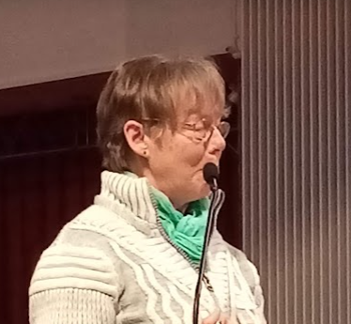Angela Scott, LLM and Anna Chaplain spoke about how maintaining digital links had kept the older people at Christ Church Chislehurst connected, during and since Lockdowns.

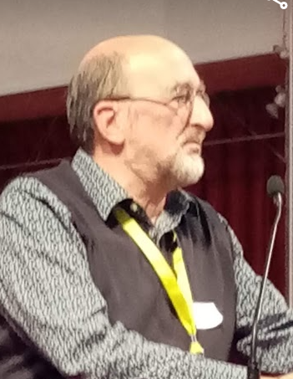
Stories

Colin Brown, Reader and Cathedral Chaplain talked about the privilege of being on the Chaplaincy Team at the Cathedral, and the faith conversations that has led to with people of all faiths and none.


Janice Bessant, Reader in Penge showed us a short film of their Holiday@Home and spoke about it as
‘A story of hope for our church, with people from the different legacy churches learning to be together in a positive way, and a story of hope for our community, with older people finding friendship and combating social isolation’
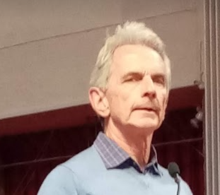Peter Kettle, LLM, updated us on the Poverty & Hope Appeal, which now includes support for our Link Dioceses. Check out the Diocesan Website, search for Poverty & Hope

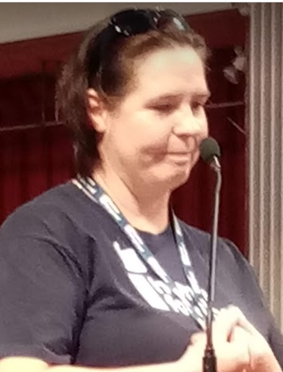
Billy-Jo O’Leary, LLM, spoke about her work for Home for Good.
Perhaps the most shocking statistic of the morning was that by the time she spoke (12.45am) 32 Children would have been taken into care that day, and that applies every day.

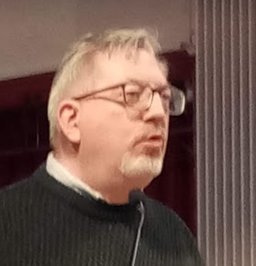
Iain Ambler, LLM spoke about his experience of Monday- Friday work being an important part of his ministry. Iain works currently in the Diocesan Office, but the same principles will apply to many workplaces and varieties of work.

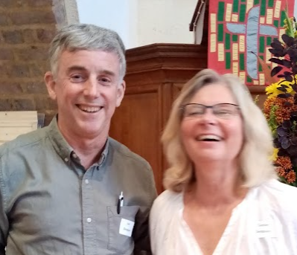

Graham Wilkinson – LLM, Growth Enabler, and Diocesan Sports Ambassador introduced Carole & Ian Simpson from Church of the Good Shepherd Borough Green, who are offering KEEP PHYTT – an opportunity for the church to connect with community, promoting health and wellbeing and helping older people live longer more active lives.
www.keephytt.co.uk

