Safeguarding Leadership Pathway

Participant Workbook

LTP One Day Version

  - Name:
  - Role:
  - Parish:
  - Course Reference Number


- Introduction
The national Safeguarding Learning and Development Framework sets out the vision for making sure that all church officers develop an appropriate level of skills and knowledge in safeguarding. A ‘church officer’ is anyone appointed or elected to a post or role by or on behalf of the Church, whether they are ordained or a layperson, paid or unpaid.
We recognise the important role leaders play in creating and maintaining a safe environment for everyone, in whatever way they support the work of the Church. We are committed to helping leaders to develop and maintain the knowledge, attitude, behaviours and skills needed to safeguard and protect children, young people and vulnerable adults.
The safeguarding leadership pathway supports our vision. It is essential that we understand safeguarding as a theological essential, rooted in the nature and love of God, and demonstrated through basic commitments to valuing everyone equally.
We are committed to developing a set of National Safeguarding Standards as part of a quality-assurance framework. The quality-assurance framework will do the following.
- Ask and answer the question, ‘How well are we doing and what is the difference or outcome being achieved?’
- Analyse the answers to this question to gain learning and strengthen the Church’s understanding of, and expertise in, safeguarding.
- Use that expertise to achieve systematic change and continuous improvement in both the quality and impact of our work, and to increase our knowledge and understanding of the changing nature of
Church-based abuse.

This learning pathway has been built around the National Safeguarding Standards.
(National Safeguarding Standards | The Church of England)

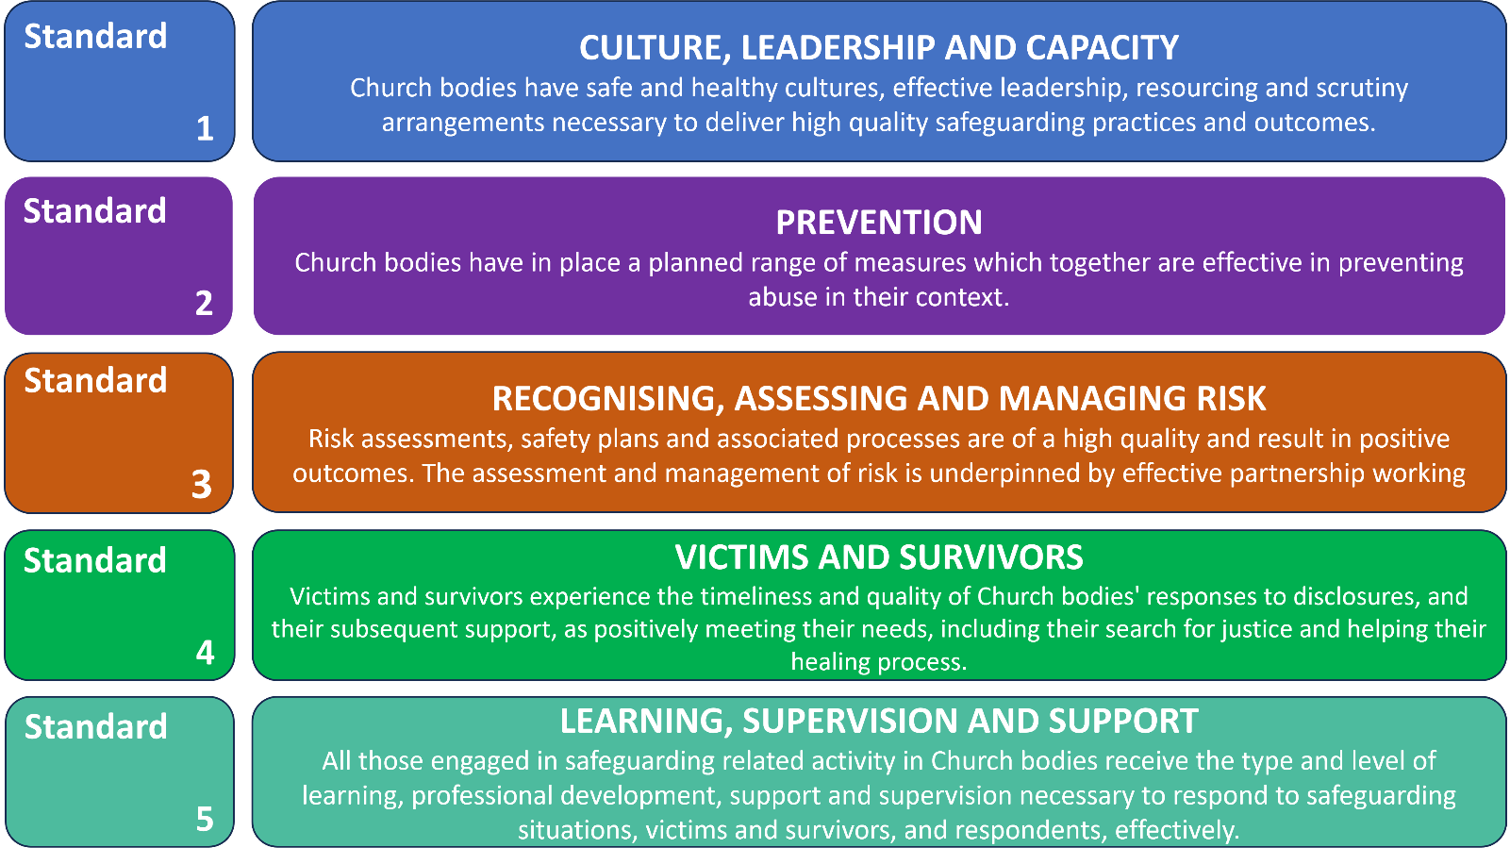
2. Learning Outcomes of this pathway
This pathway is intended to be transformational. The aim is that once you have completed it, you will be in some way different from the person you were at the start. We want you to reflect deeply on your own values and beliefs and combine these with the values and beliefs that are at the heart of good safeguarding behaviour. The idea is that good safeguarding behaviour can then flow from an inner motivation, rather than it being experienced as an external process that you must (rather than want to) follow.
By the end of this pathway, you will:
  - understand how healthy culture, and safe and effective leadership, shapes Christian communities that are healthy, safe and able to deliver high-quality safeguarding practices;
  - understand how safeguarding concerns and abuse can be prevented in your church;
  - recognise when risk-assessment and risk-management processes are needed and understand when, why and how they must be used;
  - understand more about how abuse and trauma can affect people’s lives, relationships and interactions with others in a community setting, leading to better responses to victims and survivors; and
  - evaluate your learning and use it to develop an individual action plan that will improve your safeguarding practice and responses.

3. Structure of this pathway
This pathway aims to encourage a process of reflective learning involving individual tasks and groupwork. The pathway consists of two sessions, with an evaluation task after the second session. This pathway reflects our National Safeguarding Standards and creates a dedicated space to explore our culture, values, beliefs and responses to safeguarding within the Church.
- The focus of the first session is on standards one and two of our National Safeguarding Standards – culture, leadership, and capacity and prevention. Creating environments in which everyone is safe and can flourish is essential to our purpose as God’s Church. Building safer, healthier cultures is all about leading by example with our attitudes and behaviours. To create safer places effectively, we must be prepared to look at our cultures – do they support this mission and vision? How do we know that we are safe and healthy?

- The focus of the second session is on standards three and four – recognising, assessing and managing risk, and victims and survivors. In exploring how to respond effectively to safeguarding concerns, and the people involved in them, the aim is to go beyond merely considering the process. This session builds on discussions around the importance of healthy culture, leadership and capacity as the foundation of good safeguarding practices and the role that they play in preventing abuse.

- The focus of the evaluation task is on standard five – learning, supervision, and support.

The pathway is one course with two sessions. You must do some preparation work before each session, and an evaluation task after the final session. You must complete all parts of the pathway to receive your certificate of completion.

4. Session preparation

Before each session you must complete some preparation work. The flow chart below summarises the pathway and the preparation work.

Workbook | - You will receive your workbook at least five weeks before the first session to give you time to read it and do the preparation work.  - You must return your filled-in workbook at least two weeks before session 1.
Session 1 | - This session is made up of three exercises which focus on culture, leadership, and capacity and prevention.
Work before session 2 | - You must:  - identify one thing that has influenced your responses, values and beliefs regarding safeguarding;  - answer four questions which focus on risk; and  - read the scene-setting and first scene of the case study.
Session 2 | - This session focuses on recognising, assessing and managing risk, and victims and survivors. It uses a case study which focuses on how healthy culture and leadership can prevent safeguarding concerns from escalating.
Evaluation | - You need to complete this six weeks after the second session to appropriately evaluate the outcomes of the course, what you have learnt from it and how you will put this into practice. You must send the evaluation to the facilitators.

Session 1
The first session focuses on the culture, leadership, and capacity and prevention standards. It will draw on the reflections made during your preparation work and your own experiences of healthy cultures. It emphasises the importance of creating environments in which everyone is safe and can flourish, explaining that this is important to our purpose as God’s Church.

A note about the preparation tasks that follow: These tasks are designed to help you prepare for the discussion in the session. There are no ‘right’ answers and if you work in more than one Church or setting, you might choose to focus on one of them. In reviewing your workbook, your trainer will be looking for evidence that you have given sufficient thought to the tasks to come to the session ready to talk about what your setting does well and/or ask questions to identify ways that Church culture and safeguarding practice can be strengthened further.

Preparing for the first session
Task 1: Reflect on each of six topics below, which are taken from the Culture Conversation Cube.
What attitudes, behaviours and values are present within your parish church or organisation? Summarise your thoughts into key bullet points for each topic. Write about the greatest strengths and any areas for development. Don’t worry if the same ideas fall into more than one area of focus – it is the thinking process that is important. We will talk about people’s reasons for their thinking in session 1.
Establish good governance  Think about the way your organisation is controlled and governed by considering these statements:  Our procedures and the expectations on people are clear, consistent and easy to understand.  Control within our organisation is not coercive and the difference between demands and requests is clear.  When dealing with complex situations, our organisation willingly seeks impartial advice from outside.  The behaviours shown by our leaders and others within our organisation are not rigid, dogmatic or controlling.  People are given genuine freedom to make choices for themselves about matters that affect their lives. | Greatest strengths and possible areas for development:
Listen well  Think about the stories that are being told about your organisation. Remember, there may be some stories about things that happened a long time ago that are still having an effect today. Use the following statements to help your thinking:  Stories being told by people outside our organisation are mostly positive.  Stories being told by people inside our organisation are mostly positive.  I know what negative stories are being told about our organisation.  Our organisation has a culture that welcomes feedback and encourages open discussion about these stories.  Our organisation has a culture that encourages us to be humble in the way we respond to issues and learn from them. | Greatest strengths and possible areas for development:
Build effective structures  Think about the written and unwritten structures, reporting lines and accountability within your organisation. Is the culture of your organisation being built on a healthy foundation? Consider the following statements:  The structures in our organisation help to develop and maintain safer, healthier cultures and practices.  I am clear about what our organisation is trying to achieve with its structure and that leadership is exercised safely.  Our leadership structure has processes in place that encourage and invite challenge, scrutiny and accountability.  The way our organisation’s structure works displays and develops safer, healthy culture.  Everyone with responsibility is offered an appropriate level of support, eg through supervision, personal development, coaching/mentoring, etc. | Greatest strengths and possible areas for development:
Manage power  Think about the formal and informal power structures within your organisation. How do you encourage equity and accountability? Use the following statements to help your thinking:  In our organisation decisions are made in a way that includes and welcomes the input of others.  Our leaders model humility and respect. They challenge any behaviours and attitudes which don’t value and treat people equally.  In our organisation I see people displaying safe and healthy attitudes, values and behaviours.  In our organisation I can see where power dynamics could create unhelpful or harmful imbalances and I feel able to talk about this openly.  I feel I could challenge the development of authoritarian or dictatorial power dynamics in our organisation’s leadership. | Greatest strengths and possible areas for development:
Model safe behaviours  Think about the everyday activities and behaviours that are accepted within your organisation. How are you avoiding habits, rituals and routines that may be harming or triggering for some people? Consider the following statements to help your thinking:  Our organisation is committed to being transparent and clearly communicates what behaviours are acceptable and permissible.  Our organisation welcomes feedback on our practices and our ways of working from people who are new.  Our organisation welcomes feedback on our practices and ways of working from people who are long-standing members.  Our routines and rituals are kept under review and reflect a safer, healthier culture.  Our routines and rituals take into account how they might affect people who may be vulnerable. | Greatest strengths and possible areas for development:
Communicate well  Think about how your organisation communicates internally and externally. How are you demonstrating that you practice what you preach? Use the following statements to help your thinking:  Our organisation communicates messages that support us to develop and maintain a safer culture.  Our organisation clearly communicates what a safe place looks like, so everybody understands what’s expected of them and others.  A commitment to being a safer place is an important part of who we are as an organisation.  I am clear about where accountability lies and that it is used to encourage personal value and equality.  Our organisation actively welcomes people who are broken, wounded and vulnerable, providing them with a safe place. | Greatest strengths and possible areas for development:

AFTER COMPLETING TASK 1, PLEASE MOVE ON TO TASKS 2 AND THREE ON THE FOLLOWING PAGES

The Code of Safer Working Practice: Code of Safer Working Practice 02.07.2021.pdf (churchofengland.org) and also provided in appendix 1 of this workbook.
The Guidelines for Professional Conduct of the Clergy: The Guidelines | The Church of England

You can buy the culture conversation cube using the following link.

https://thirtyone-eight-charity.myshopify.com/products/culture-conversation-cube?pr_prod_strat=use_description&pr_rec_id=0e8478ce9&pr_rec_pid=7266692694202&pr_ref_pid=6764450742458&pr_seq=uniform

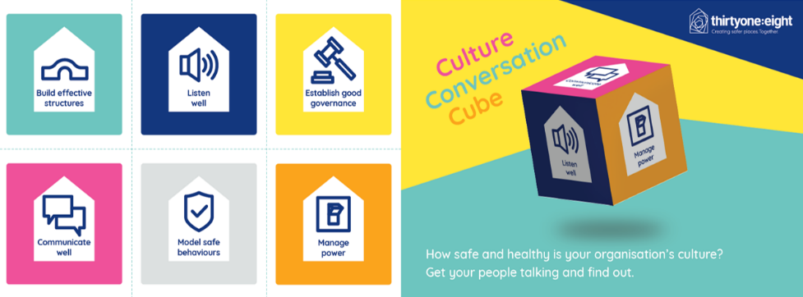
Task 2: Reflecting on Healthy Culture

Complete a written reflection in response to each of the questions below. There is no set word count or structure for these reflections, but 250 to 300 words for each question is a useful guide. Feel free to use bullet points if you prefer.

This personal reflection can also be shaped by your experience of attending the last version of the leadership pathway (if this applies) and by reading the recommended texts listed in appendix 2. It is not essential to read the recommended texts as not everyone will have the time to do this.

Question 1: If your church were a perfect example of a healthy culture, what would you see, hear, feel and experience as a member?

Question 2: How could your church, its healthy culture and the way it is experienced help prevent safeguarding issues?

Task 3: Social GGRRAAAACCEEESSS

The ‘social graces’ task is a thinking task, but there is no need to record it in your Workbook.
The ‘social graces’ include:
G – gender, geography
R – race, religion
A – age, ability, appearance, accent
C – class, culture
E – ethnicity, employment, education
S – sexuality, sexual orientation, spirituality, something else

The ‘social graces’ framework helps us to think about and understand parts of our identity;

who we are

how our own identity affects how we think

how others might think about us.

The framework also helps us to think about the power we might hold within relationships because of our identity.

How do these characteristics affect how you respond to others? Use the following daisy diagram to reflect on your own identity and how this influences your interaction with others.
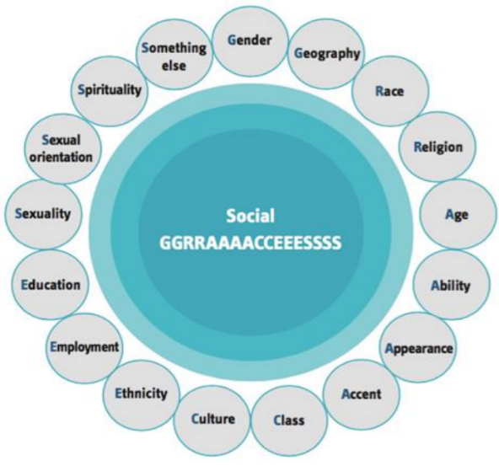

What factors from your own life experiences, history and characteristics could affect your beliefs, values and emotions?

- How does this affect the way you respond to others>

- How does this impact how you are seen by others?

If you wish, you can explore the theory behind social graces further by accessing the materials available on the Safeguarding training Portal: https://safeguardingtraining.cofeportal.org/course/view.php?id=436.

You should email your filled-in workbook to ruth.campbell@rochester.anglican.org. This will give time for facilitators to prepare for the discussion that will take place during the session. If you do not send your workbook within this time, or if your answers show that no real thought or reflection has taken place, we will ask you to complete the preparation work before inviting you to join the rest of the pathway. You must also provide evidence that you have completed the Basic Awareness and Foundation level modules.

ONCE YOU HAVE COMPLETED THE THREE TASKS REQUIRED BEFORE SESSION 1, PLEASE RETURN YOUR WORKBOOK TO THE TRAINER
Session 2

The second session focuses on the standards of recognising, assessing and managing risk, and victims and survivors. It draws on the discussions from the first session, which focused on healthy culture, leadership and capacity, using a case study that emphasises how safeguarding concerns can be prevented from escalating.

Preparation for the second session
Task 1: Identify what has influenced your values and beliefs regarding safeguarding.
Please identify one thing that reflects what has influenced your individual connection with safeguarding and what your values and beliefs regarding safeguarding are based on. For example, this might be linked to song lyrics, nature or literature, or may depend on your own theology, religious scripture or teachings.
Please come prepared to this session. You should be able to share what has influenced you and explore how this has shaped your responses, values and beliefs regarding safeguarding.
Examples
Thomas Jefferson / Mahatma Gandhi “The true measure of any society can be found in how it treats its most vulnerable members.”
“Speak up for those who cannot speak for themselves, for the rights of all who are destitute. Speak up and judge fairly; defend the rights of the poor and needy.” (Proverbs 31:8).
Proverb: “It takes a village to raise a child.”
And you shall love the Lord your God with all your heart and with all your soul and with all your mind and with all your strength.’ The second is this: ‘You shall love your neighbour as yourself.’ There is no other commandment greater than these.” Mark 12:30-31 (English Standard Version)

What has influenced and therefore underpins your values and beliefs regarding safeguarding?

If you have an image, text or sound clip in response to this question that you would like to share with the group during session 2, please send it to the training facilitator at least 48 hours before session 2. Thank you!

Task 2: Recognising, assessing and managing risk
Reflect on the questions below, which are designed to focus our minds on recognising, assessing, and managing risk.

On a scale of 0 to 10, where 0 is 'not at all confident’ and 10 is ‘extremely confident’, how confident are you in recognising and managing risk? What supports your score?

Now think about what safeguarding risks exist in your own Church or context. Think about what is working well and what can be improved. For example, some Churches have recognised that how the congregation share the Peace with one another needed rethinking. Other Churches have explored how safeguarding information can be made more accessible to certain groups in their congregation, eg children, victims of certain forms of abuse. Record your thoughts about your own context here.
What safeguarding risks exist in your own church? What are you worried about?
- What challenges have you experienced in managing a known safeguarding risk?
- How should these risks be managed or reduced? (And how are they managed or reduced?) What is working well and what can we do to improve?

Task 3: Case Study

Read scene 1 of the case study below so you are familiar with the characters and the scenario. We’ll discuss the case study during session 2.

Characters and setting the scene

Ash is the vicar of St Elsewhere’s Parish Church and is married to Kim, who leads the Pastoral team and heads up the Wednesday Afternoon Club. The club membership is mainly retired folk.

Sofia is a widow and a retired nurse, who lives alone in a flat in the Parish. She worships regularly at St Elsewhere’s. Sofia is beginning to show early signs of dementia, but is still very capable of independent living and is known to use the internet to communicate with her son and his family who live in New Zealand.

Lola is Sofia’s daughter and is married to Alex. They have a 5 year old twins. The family regularly attend Sunday services at St Elsewhere’s and the boys enjoy attending Sunday School. They live a few minute’s walk from Sofia.

Claude is the Parish Safeguarding Officer at St Elsewhere’s Parish Church.

Mavis is the twins’ Sunday School teacher and a neighbour of Sofia.

Scene 1

Sofia has enjoyed attending the Wednesday afternoon club for a number of years. She has always been friendly and outgoing and enjoys meeting her friends there each week. It has been noted that over recent weeks she seems to have lost a little weight, but she always has a good appetite for cake with her cup of tea at the club.

One afternoon, Sofia seems very distant and unusually quiet. Kim comes to sit with Sofia at refreshment time and gently enquires if everything is OK. After a brief hesitation, Sofia tells Kim that she is worried about Lola and the family. They haven’t told anyone, but Alex has lost his job. Sofia says that Lola has always been hopeless at managing money and the family is now struggling financially. Kim is concerned about what Sofia has told her. She acknowledges Sofia’s worries and suggests that she could find details of helpful support agencies that Sofia could pass on to Lola. Sofia thinks this is a good idea and expresses how grateful she is. She seems to cheer up a little after talking to Kim.

Bringing together and evaluating the learning

Traditionally, evaluation in safeguarding training – across all sectors, not just the Church – tends to focus on people reporting on their own experience of a training session they have attended. The problem with this is that it doesn’t really tell us whether training is having any effect. Do people just attend a training event, tick a box on the evaluation sheet and then carry on as before?

The evaluation that really matters is whether the learning experience has affected someone’s beliefs, values and understanding so deeply that there is a change in their behaviour. They now do things because they really want to, not because they have to. This is called ‘second order’ change and means that people do things because there is an inner motivation.

If this learning experience has been effective, you will, in some respects, be a different person from the one who started the experience.

The purpose of evaluation is to try to find out if the training has changed you.
At the beginning of the workbook, we set out the learning outcomes the programme is designed to deliver, and we have repeated them below.
By the end of this pathway, you will:
  - understand how safeguarding concerns and abuse can be prevented in your church;
  - understand how healthy culture, and safe and effective leadership, shapes Christian communities that are healthy, safe and able to deliver high-quality safeguarding practices;
  - recognise when risk-assessment and risk-management processes are needed and understand when, why and how they must be used;
  - understand more about how abuse and trauma can affect people’s lives, relationships and interactions with others in a community setting, leading to better responses to victims and survivors; and
  - evaluate your learning and use it to develop an individual action plan that will improve your safeguarding practice and responses.

If this learning programme has been successful, there will be evidence of the above behaviours, and other people will be able to see a change in your behaviour.

The evaluation task

Six weeks after the second session, complete the self-reflection (on the next page) to show how you have applied the learning from this pathway. Write an action plan which shows three to four ways that you will include what you have learnt in your safeguarding practices. Once you have completed your self-reflection and action plan, send them to the facilitator for them to review.

Leadership Safeguarding Pathway - Self-reflection and action plan.

Your name: _____________________________Location: ____________________________

Role: ____________________________________________ Date: ____________________

It is important that our leaders maintain the knowledge, attitudes and skills needed to safeguard and protect children, young people and vulnerable adults. They must also understand safeguarding as a theological essential, rooted in the nature and love of God and demonstrated in behaviour, attitudes and language that give equal value to everyone.
The overall aim is to bring about a shift in our relationship with safeguarding, so that guarding the safety of others flows from the very core of all our behaviour. Safeguarding is more than about ticking a box – it must be at the heart of everything we do.

Self-reflection
Having now completed the leadership safeguarding pathway, please reflect on what you have learnt from the sessions and how you have included this in your practice.
- What difference have you noticed in your approach to safeguarding? (For example, think about knowledge, attitude, language, importance and inclusion within your work.)

- What opportunity do you have, or could you use, to create a healthy church community?

- What would it look like for you to demonstrate behaviour that gives equal value to everyone?

Action Plan
Developing a four- to six-month action plan will allow you to practise new leadership behaviour which others can see and which achieves real safeguarding outcomes. It also demonstrates that safeguarding is becoming increasingly natural to you and is at the heart of everything you do.

When developing this action plan, consider how you would use what you have learnt to:
  - reflect on how safeguarding concerns and abuse could be prevented in your church;
  - consider how healthy culture, and safe and effective leadership, shapes Christian communities that are healthy, safe and able to deliver high-quality safeguarding practices;
  - recognise when risk-assessment and risk-management processes are needed and understand when, why and how they must be used;
  - understand more about how abuse and trauma can affect people’s lives, relationships and interactions with others in a community setting, leading to better responses to victims and survivors; and
  - evaluate what you have learnt and use it to develop an individual action plan that will improve your safeguarding practice and responses.

When creating your action plan think ‘SMART’.
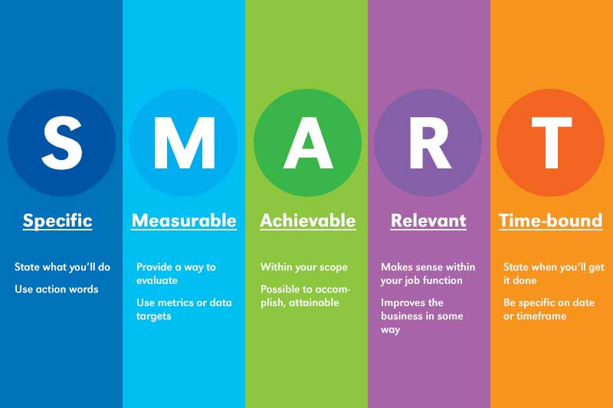

We would suggest that you develop three to four objectives for the next six to eight months.
It would also benefit your own learning and church to discuss your action plan with colleagues who might be able to support or contribute to your action plan.

SMART Action Plan
Objective  What would you like to achieve? | Task/s  What do you need to do? | Success Criteria  What will it look like if you achieve your objective? | Timescale  When would you like to achieve this?

APPENDIX 1: The Code of Safer Working Practice
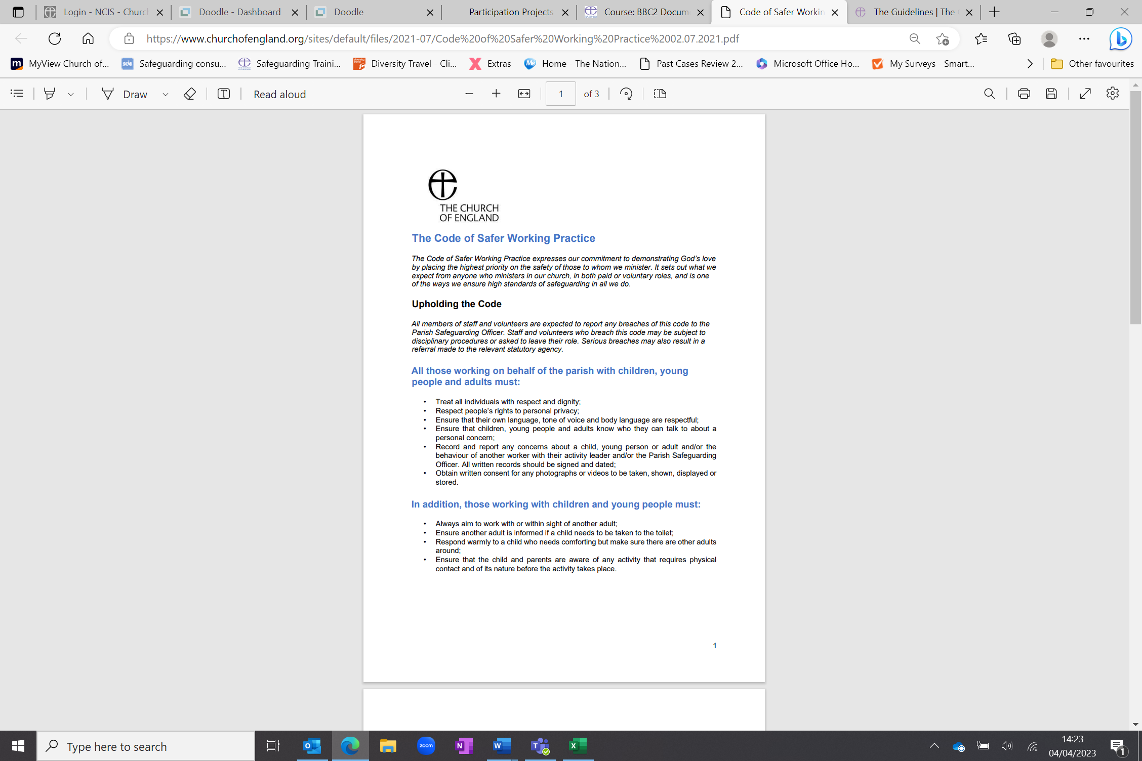

The Code of Safer Working Practice

The Code of Safer Working Practice expresses our commitment to demonstrating God’s love by placing the highest priority on the safety of those to whom we minister. It sets out what we expect from anyone who ministers in our church, in both paid or voluntary roles, and is one of the ways we ensure high standards of safeguarding in all we do.

Upholding the Code

All members of staff and volunteers are expected to report any breaches of this code to the Parish Safeguarding Officer. Staff and volunteers who breach this code may be subject to disciplinary procedures or asked to leave their role. Serious breaches may also result in a referral made to the relevant statutory agency.

All those working on behalf of the parish with children, young people and adults must:

- Treat all individuals with respect and dignity;
- Respect people’s rights to personal privacy;
- Ensure that their own language, tone of voice and body language are respectful;
- Ensure that children, young people and adults know who they can talk to about a personal concern;
- Record and report any concerns about a child, young person or adult and/or the behaviour of another worker with their activity leader and/or the Parish Safeguarding Officer. All written records should be signed and dated;
- Obtain written consent for any photographs or videos to be taken, shown, displayed or stored.

In addition, those working with children and young people must:

- Always aim to work with or within sight of another adult;
- Ensure another adult is informed if a child needs to be taken to the toilet;
- Respond warmly to a child who needs comforting but make sure there are other adults around;
- Ensure that the child and parents are aware of any activity that requires physical contact and of its nature before the activity takes place.

All those working on behalf of the parish with children, young people and adults must not:

- Use any form of physical punishment;
- Be sexually suggestive about or to an individual;
- Scapegoat, ridicule or reject an individual or group;
- Permit abusive peer activities e.g. initiation ceremonies, ridiculing or bullying;
- Show favouritism to any one individual or group;
- Allow an individual to involve them in excessive attention seeking;
- Allow unknown adults access to children, young people and adults who may be vulnerable. Visitors should always be accompanied by an approved person;
- Allow strangers to give lifts to children, young people and adults who may be vulnerable in the group;
- Befriend children, young people and adults who may be vulnerable on social media;
- Take photographs on personal phones or cameras as this means that images are stored on personal devices.

In addition, for children and young people, must not:

- Give lifts to children you are supervising, on their own or your own (unless there are exceptional circumstances e.g. in an emergency for medical reasons or where parents fail to collect a child and no other arrangements can be made to take a child home. In such situations, the circumstances and your decision must be recorded and shared with an appropriate person at the earliest opportunity);
- Smoke or drink alcohol in the presence of children and young people, except when this is a social situation with family members/carers present, eg a parish party¹
- Arrange social occasions with children and young people (other than events which also include family members/carers) outside organised group occasions.

Acceptable Touch

Sympathetic attention, encouragement and appropriate physical contact are needed by children and adults. Some physical contact with children, particularly younger children, can be wholly appropriate. However, abusers can use touch that appears safe to ‘normalise’ physical contact which then becomes abusive. As a general rule, the use of touch between adults in positions of responsibility and those with whom they are working or volunteering should be initiated by the person themselves, and kept to the minimum. In addition to this, always follow the guidelines below:

- Ask permission before you touch someone;
- Allow the other person to determine the degree of touch except in exceptional circumstances (e.g. when they need medical attention);
- Avoid any physical contact that is or could be construed as sexual, abusive or offensive;
- Keep everything public. A hug in the context of a group is very different from a hug behind closed doors;
- Touch should be in response to a person’s needs and not related to the worker’s needs. Touch should be age appropriate, welcome and generally initiated by the child, not the worker

_______________________________________
¹ For the avoidance of doubt this document does not apply to church services, including Holy Communion.

APPENDIX 2: Further information/resources and websites.
Relevant texts

Oakley & Humphries (2019), Escaping the Maze of Spiritual Abuse. Creating Healthy Christian Cultures. SPCK Publishing https://spckpublishing.co.uk/escaping-the-maze-of-spiritual-abuse
Fife, Janet and Gilo (2019), Letters to a Broken Church. Ekklesia
Harper and Wilson (2019), To Heal and Not to Hurt: A fresh approach to safeguarding in Church. Darton, Longman and Todd
Merchant (2020), Broken by Fear, Anchored in Hope: Faithfulness in an age of anxiety. SPCK Publishing https://spckpublishing.co.uk/broken-by-fear-anchored-in-hope
Frankl, Viktor (2004), Man's Search for Meaning: The classic tribute to hope from the Holocaust. Rider
Atkinson (2014), Struggling to Forgive: Moving on From Trauma. Monarch Books

Atkinson (2006), Breaking the Chains of Abuse: A Practical Guide. Lion Books

Gardiner (2021), Sex, Power, Control: Responding to Abuse in the Institutional Church. www.lutterworth.com

Honeysett (2022), Powerful Leaders: When Church Leadership Goes Wrong and How to Prevent It. www.thegoodbook.co.uk

Graystone (2021) Bleeding for Jesus. Darton, Longman and Todd
www.dartonlongmantodd.co.uk

MacFarlane (2021) Going Public: A survivor’s journey from grief to action.
Going Public a Survivor's Journey from Grief to Action by Julie Macfarlane - Paperback / softback - 9781771134750 (hymnsam.co.uk)

The Independent Inquiry into Child Sexual Abuse, Report on The Anglican Church
The Anglican Church: Safeguarding in the Church of England and the Church in Wales (iicsa.org.uk)
The National Report on Past Cases Review 2
Past Cases Review 2 - National Report.pdf (churchofengland.org)
The SCIE overview report
SCIE Final overview report of the independent diocesan safeguarding audits and additional work on improving responses to survivors of abuse.pdf (churchofengland.org)
The Church of England’s safeguarding policies
https://www.churchofengland.org/safeguarding/promoting-safer-church/policy-practice-guidance
Websites

www.nspcc.org.uk (National Society for the Prevention of Cruelty to Children)
www.womensaid.org.uk (female domestic abuse charity)
www.restoredrelationships.org (Christian domestic abuse charity)
www.mankind.org.uk (male domestic abuse charity)
www.stopitnow.org.uk (child safeguarding organisation)
www.scie.org.uk (Social Care Institute for Excellence)
www.ceop.police.uk (child exploitation and online protection command)
www.wearehourglass.org (adult safeguarding charity)
www.ageuk.org.uk (adult safeguarding charity)
www.barnardos.org.uk (child protection charity)
www.theclewerinitiative.org (modern slavery charity)
www.modernslavery.co.uk (modern slavery charity)
www.macsas.org.uk (survivor advocacy charity)
https://houseofsurvivors.org/
https://survivingchurch.org/
APPENDIX 3: Helplines for further support
- Safe Spaces –
Safe Spaces is for anyone who feels they have experienced church related abuse of any form in England or Wales. Safe Spaces comprises a team of trained support advocates who have undergone specialist training in supporting survivors of sexual violence and who have received additional specific training in how the churches respond to abuse cases, the way in which faith and church-related settings have been used to carry out abuse, and the issues affecting people who have had or still have, a relationship with the church. You can contact the Safe Spaces team by: -
Tel: 0300 303 1056
(Answerphone available outside of opening times)
Email: safespaces@firstlight.org.uk
A live chat service is also available through the Safe Spaces website - Safe Spaces England and Wales – Safe Spaces England and Wales
The Safe Spaces team are available through their helpline and live chat service on:
Opening Times: Monday - Friday: 9am-9pm Saturday: 9am-1pm Sunday: 1pm-5pm

- NSPCC - For adults concerned about a child 0808 800 5000
- ChildLine - For children and young people on 0800 1111
- Action on Elder Abuse helpline 0808 808 8141
- 24-hour National Domestic Violence Helpline 0808 2000 247
- NAPAC – Offer support and advice to adult survivors of childhood abuse 0808 801 0331
- Stop It Now – preventing child sexual abuse 0808 1000 900
- Cruse – bereavement helpline 0808 808 1677

