It’s more than money!
We may have different amounts of money, we have different abilities and talents, but we each have 168 hours in a week. No matter what we do, we cannot create more time, or experience less of it. We can, however, make different choices about what we do with our time.
Our talents and gifts, like all of our possessions and wealth, are generous gifts from a generous God. These gifts which we have been given are offered back to God as we use them within the Church. This is true of musical, teaching, financial, and academic talents, but it is also true of the spiritual gifts we have received.
What gifts do we have and how can we use them for God?

Think about planned giving...
Planned giving means that you decide to give a set amount to the church each week, month or year. Most people set up a standing order, which is easy and convenient, or you can use a weekly or monthly envelope.
By joining the planned giving scheme, if you are not already part of it, you will make a big difference to our church’s finances. Your contribution will be working for our church and community whether you are there on Sunday or not, it will be easier to Gift Aid the donation, and the treasurer will have a better idea of how much income the church will have. and what is possible for the future.

What we give ...
is a matter between ourselves and God. What He expects of us is that we should each shoulder our responsibility as a member of the family of our church to the best of our ability.

The next step ...
Thank you for all you do for our church. Using the form provided please:

- Think about what you give to the church
now. Can you increase the percentage of your income which you give to God?
- Join the planned giving scheme with
weekly or monthly envelopes, or a standing order.
- Give proportionately - a percentage of our income given to fund ministry.

Please make your response
using the form provided by Friday 10th June
This ministry not only supplies the needs of the saints but overflows with many thanksgivings to God.
2 Cor 9:12

St Mary’s Church
Anywhere

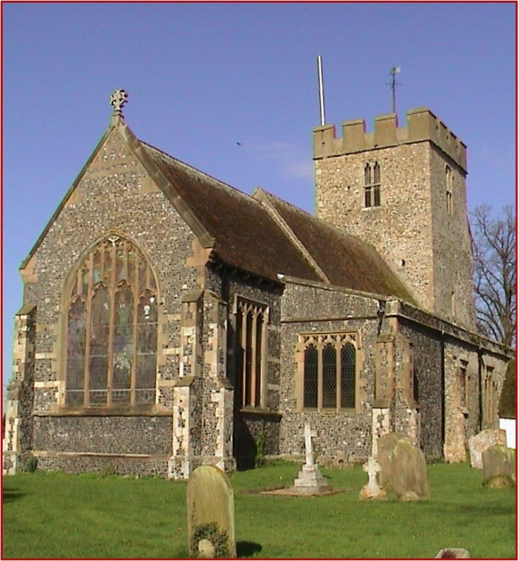

Stewardship Sunday 2016

Our church ...
We believe that our church, St Mary’s is special. Our wonderful and varied congregation enjoys a wide range of worship and activities, from flower festivals and quiz nights to lunches, suppers and social events.

We have good links with our local care home and have a range of other activities for our children including Junior Church and Messy Church.

Thank you
None of our churches’ activities could happen without you. Many of you give very generously of your time, and skills and abilities, as well as your financial gifts. Thank you. Without your contribution our church would not be here today.

But we need to do more!
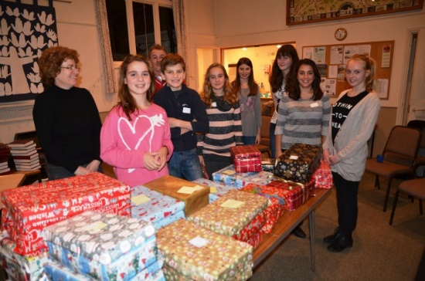
We have an ageing congregation and would like to see many more young families join us and become part of our Church, but to do this we would need to increase our income, and at present there is a shortfall in our income of nearly £xxx per week.

Our church finances ...
Our current weekly expenditure is ...

Admin & ministry expenses £000 Church and Services £000
Parish Share £000
Giving outside the parish £000
Sundries £000

Total £0000
Our weekly income is ...

Planned giving £000
Cash collections £000
Fundraising income £000
Hall letting income £000
Other £000

Total £0000

What is the Parish Share?
The parish share is a financial contribution made by every parish to support the ministry and mission of our churches. Without it our churches and the Diocese would be unable to function.

Why should we give?
Our giving of both money and time supports the mission of God in the world – both here in Anywhere and further afield. Our reason for giving to the church isn’t about paying the gas bill, but rec- ognising that in being a disciple of Christ I should put God first in my life.
My giving is my gift to God, to enable his Church to flourish.
In the Parish our current giving is almost enough to cover our current running costs, but if we want to look to the future and support new mission and community initiatives we will need to do more.

How much money should we give?

Obviously it is not just a case of everyone giving the same amount extra every week - that would be unfair as some of us already give more than we can afford. After reviewing your giving you may be able to give a little more to the church.
The scriptures teach the principle of proportion- ate giving, or tithing – giving a percentage of our income to the church. The General Synod of the Church of England suggests a figure of 5% of our net income – that is our income after tax, but be- fore any other expenses.

But just as you excel in everything …see that you also
excel in this grace of giving

