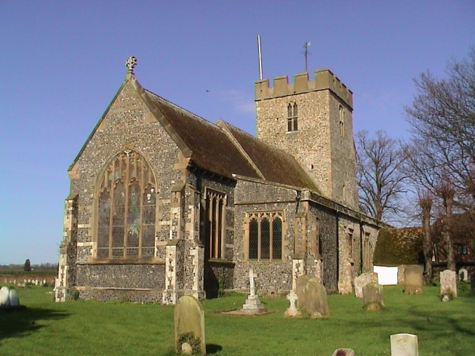
St Mary’s Church
Anywhere

You are warmly invited to a presentation which will be of great interest to everyone who is part of our parish family. It will take place during the special service on
Sunday, 24th April at 10.15am
The Service will include a presentation on the future resourcing of our Church.
St Mary’s Church
Anywhere

You are warmly invited to a presentation which will be of great interest to everyone who is part of our parish family. It will take place during the special service on
Sunday, 24th April at 10.15am
The Service will include a presentation on the future resourcing of our Church.

St Mary’s Church
Anywhere

You are warmly invited to a presentation which will be of great interest to everyone who is part of our parish family. It will take place during the special service on
Sunday, 24th April at 10.15am
The Service will include a presentation on the future resourcing of our Church.
St Mary’s Church
Anywhere

You are warmly invited to a presentation which will be of great interest to everyone who is part of our parish family. It will take place during the special service on
Sunday, 24th April at 10.15am
The Service will include a presentation on the future resourcing of our Church.

