Suggested text
Please use and adapt the text as you find helpful. Some key graphics are also included. If you need any further help, please email: communications@rochester.anglican.org

Pew sheets, newsletters, emails
Did you know? In March 2025, the Diocese of Rochester secured nearly £11 million of funding from the National Church to support the Called Together vision.
This is a nine-year programme of work to grow missional churches, with missional leaders and missional disciples.

This is the largest external funding award the Diocese has received in support of mission and ministry. It is designed to enrich every church setting.
An update has just been shared about how work around the vision is progressing. To read it, SCAN the code or visit: www.rochester.anglican.org/about-us/ourvision/progress-updates/ OR pick up a printed sheet as you leave church today.
Growing God’s kingdom across the Diocese of Rochester
Our church is part of the Diocese of Rochester. As a family of faith across Medway, north and west Kent, and the London Boroughs of Bromley and Bexley, we are on a shared journey to grow God’s Kingdom.
This diocesan-wide plan – known as Called Together - has received nearly £11 million from the National Church to support work to make this vision a reality.
Read the latest update on how work is progressing by SCAN the code or visit: www.rochester.anglican.org/about-us/ourvision/progress-updates/ OR pick up a printed sheet as you leave church today.

Called Together progress update now available
In the latest update on the diocesan-wide Called Together vision, find out about the additional support now available to help support parishes in areas such as children and youth work, and care of buildings, as well as how we can pray for all that is underway.
Read the latest update by SCANNING the code or visit: www.rochester.anglican.org/about-us/ourvision/progress-updates/ OR pick up a printed sheet as you leave church today.
Graphics
(Right click on an image and choose ‘Save picture as’)
Progress update QR code

Overall expected outcomes by 2034
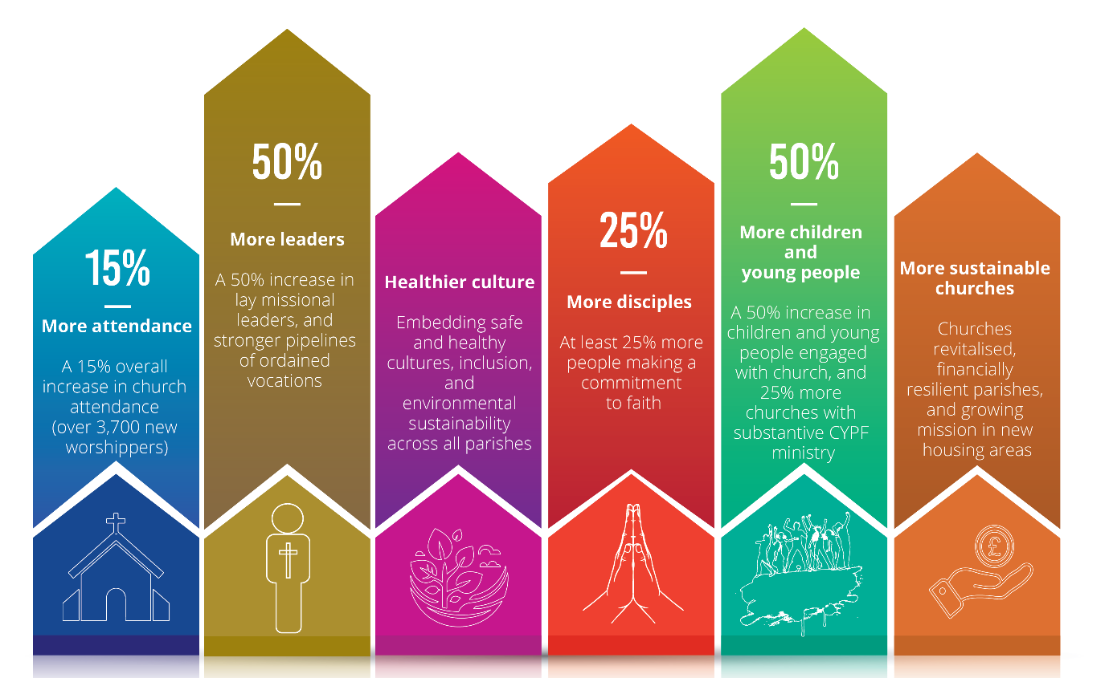

Diocese of Rochester logo including Called Together


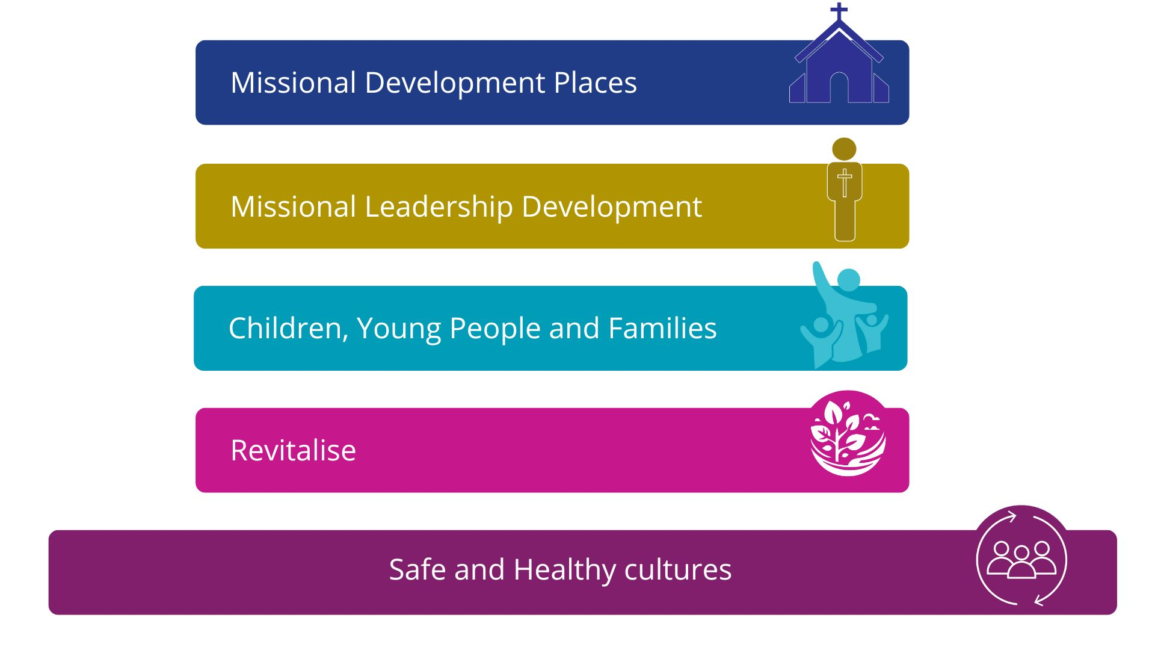
The four workstreams underpinned by safe and healthy cultures
Called Together collage image
